# **PASSERSMATE: AN ONLINE JOB MARKETPLACE FOR**

# **TECHNICAL AND VOCATIONAL SKILLS**

**A Research / Capstone Project presented to the Faculty of the**

**College of Computer Studies, University of Cebu**

**In Partial Fulfillment of the Requirements**

**for the degree Bachelor of Science in Information Technology**

**By**

**Franco, Marvee Yofa D.**

**Prialde, Syrel**

**Abuga, Joel Lemuel**

**Mr. Joaquin S. Patiño**

**Adviser**

**September 2018**

**APPROVAL SHEET**

This Research or Capstone Project Study entitled **PASSERSMATE:AN ONLINE JOB MARKETPLACE FOR TECHNICAL AND VOCATIONAL SKILLS** prepared and submitted by Marvee Yofa D. Franco, Syrel Prialde, and Joel Lemuel Abuga has been examined and is recommended for approval and acceptance.

RECOMMENDED:

**Joaquin S. Patiño, BSIT Bell Campanilla, MSIT**

Adviser IT Research Coordinator

\_\_\_\_\_\_\_\_\_\_\_\_\_\_\_\_\_\_\_\_\_\_\_\_\_\_\_\_\_\_\_\_\_\_\_\_\_\_\_\_\_\_\_\_\_\_\_\_\_\_\_\_\_\_\_\_\_\_\_\_\_\_\_\_\_\_\_\_\_\_\_\_\_\_\_\_\_\_

APPROVED by the Examining Tribunal on ***Oral Defense*** with a group verdict of

\_\_\_\_\_\_\_\_\_\_\_\_\_\_\_\_\_\_\_\_\_\_\_\_\_\_\_ on \_\_\_\_\_\_\_\_\_\_\_\_\_\_\_\_\_\_\_\_\_\_\_.

**Melvin M. Niñal, PhD.**

Chairman

**Bell Campanilla, MSIT Neil A. Basabe, MIT**

Member Member

\_\_\_\_\_\_\_\_\_\_\_\_\_\_\_\_\_\_\_\_\_\_\_\_\_\_\_\_\_\_\_\_\_\_\_\_\_\_\_\_\_\_\_\_\_\_\_\_\_\_\_\_\_\_\_\_\_\_\_\_\_\_\_\_\_\_\_\_\_\_\_\_

ACCEPTED and APPROVED in partial fulfillment of the requirements in Bachelor of Science in Information Technology.

**Melvin M. Niñal, PhD.**

Dean, UC-CCS

Date: **\_\_\_\_\_\_\_\_\_\_\_\_\_\_\_\_\_**

# **ABSTRACT**

# **ACKNOWLEDGEMENT**

Different kinds of personas, different kinds on knowledge, but still these people supported and helped to make this project possible. We would like to extend our utmost appreciation to:

**Almighty God**, for the guidance, strength, support, and courage he gave us during the study.

**To Mr. Joaquin S. Patiño,** our great adviser for correcting our mistakes, sharing his thoughts and ideas and guiding us through the way. His guidance created a way for us to improve and think outside the box.

**To the two amazing people, Mr. Pablo Franco and Mr. Amie Minguito,** for their unprecedented care, support and ideas shared to us.

**Our beloved parents and siblings**, for their sacrifice, financial and spiritual support, for understanding our struggles and all the pieces of advice they have given. **The Researchers**

# **DEDICATION**

We dedicate this study to our ever-loving parents for their undying support and guidance from the very beginning. To our friends and colleagues who helped us in their own little way. To our mentors and adviser who dedicated their lives for the students to learn. They are our inspiration to keep us going despite all the hindrances. With their love and support, this project would not have been made possible without their own way of supporting us. Most especially to our Almighty God, blessings, knowledge, the people that help us and guidance. May God bless us all.

# **TABLE OF CONTENTS**

[PASSERSMATE: AN ONLINE JOB MARKETPLACE FOR i](#_Toc509934299)

[TECHNICAL AND VOCATIONAL SKILLS ii](#_Toc509934300)

[ACKNOWLEDGEMENT iii](#_Toc509934301)

[DEDICATION vi](#_Toc509934302)

[TABLE OF CONTENTS v](#_Toc509934303)

[LIST OF TABLES vi](#_Toc509934304)

[LIST OF FIGURES vii](#_Toc509934305)

[CHAPTER I 1](#_Toc509934306)

[INTRODUCTION 1](#_Toc509934307)

[Rationale of the Study 1](#_Toc509934308)

[Objectives of the Study 2](#_Toc509934309)

[Scope and Limitations of the Study 3](#_Toc509934310)

[Significance of the Study 4](#_Toc509934311)

[Flow of the Study 5](#_Toc509934312)

[Definition of Terms 6](#_Toc509934313)

[CHAPTER II 9](#_Toc509934314)

[REVIEW OF RELATED LITERATURE AND STUDIES 9](#_Toc509934315)

[Related Literature 9](#_Toc509934316)

[Related Studies 10](#_Toc509934317)

[Comparative Matrix / Competitor’s Analysis 13](#_Toc509934318)

[Legal Bases 14](#_Toc509934319)

[CHAPTER III 16](#_Toc509934320)

[RESEARCH METHODOLOGY 16](#_Toc509934321)

[Software Engineering Methodology 16](#_Toc509934322)

[Planning or Conception-Initiation Phase 17](#_Toc509934323)

[Business Model Canvas 17](#_Toc509934324)

[Program Workflow 18](#_Toc509934325)

[Validation Board 19](#_Toc509934326)

[Gantt Chart 21](#_Toc509934327)

[Functional Decomposition Diagrams 23](#_Toc509934329)

[Analysis-Design Phase 23](#_Toc509934330)

[Use Case Diagrams 23](#_Toc509934331)

[Storyboard 26](#_Toc509934332)

[Database Design 38](#_Toc509934334)

[Entity-Relationship Diagram 38](#_Toc509934335)

[Data Dictionary 40](#_Toc509934336)

[Network Design 47](#_Toc509934337)

[Development/Construction/Build Phase 48](#_Toc509934338)

[Technology Stack Diagram 49](#_Toc509934339)

[Software Specification 49](#_Toc509934340)

[Hardware Specification 50](#_Toc509934341)

[Program Specification 51](#_Toc509934342)

[List of Modules 51](#_Toc509934343)

[CONCLUSION 55](#_Toc509934344)

[RECOMMENDATIONS 56](#_Toc509934345)

[PROJECT ROADMAP 57](#_Toc509934346)

[REFERENCES 58](#_Toc509934347)

[CURRICULUM VITAE 59](#_Toc509934348)

[APPENDICES 62](#_Toc509934349)

[A. Oath of Confirmation 62](#_Toc509934350)

[B. Capstone Project Team Composition Form 63](#_Toc509934351)

[C. Capstone Project Working Title Form 64](#_Toc509934352)

**LIST OF TABLES**

[COMPARATIVE MATRIX 13](#_Toc509934512)

[CUSTOMER VALIDATION STAGE 1 19](#_Toc509934517)

[CUSTOMER VALIDATION STAGE 2 20](#_Toc509934519)

[DATA DICTIONARY - Seeker 40](#_Toc509934557)

[DATA DICTIONARY - Multimedia 41](#_Toc509934559)

[DATA DICTIONARY - Subscription 41](#_Toc509934561)

[DATA DICTIONARY - Message 41](#_Toc509934563)

[DATA DICTIONARY - OfferJob 42](#_Toc509934565)

[DATA DICTIONARY - CancelJob 42](#_Toc509934567)

[DATA DICTIONARY - Notification 43](#_Toc509934569)

[DATA DICTIONARY - Passer 43](#_Toc509934571)

[DATA DICTIONARY - PasserSkills 44](#_Toc509934573)

[DATA DICTIONARY - CertificateOfEmployment 44](#_Toc509934575)

[DATA DICTIONARY - Admin 45](#_Toc509934577)

[DATA DICTIONARY - SubscriptionType 45](#_Toc509934579)

[DATA DICTIONARY - Documents 45](#_Toc509934581)

[DATA DICTIONARY - Dispute 45](#_Toc509934583)

[DATA DICTIONARY - PasserWorkHistory 46](#_Toc509934585)

[DATA DICTIONARY - SwitchAccount 46](#_Toc509934587)

[DATA DICTIONARY - SubSkill 46](#_Toc509934589)

[DATA DICTIONARY – Review 47](#_Toc509934591)

[SOFTWARE SPECIFICATION 50](#_Toc509934595)

[HARDWARE SPECIFICATION 50](#_Toc509934597)

[LIST OF MODULES 51](#_Toc509934599)

# **LIST OF FIGURES**

[Figure 1: Flow of the Study 6](#_Toc509935039)

[Figure 2: Catalyzer 10](file:///C:\Users\MarveeLoper\Desktop\PASSERSMATE-FINAL\PROJECT_PASSERSMATE.docx#_Toc509935040)

[Figure 3: Raket 11](file:///C:\Users\MarveeLoper\Desktop\PASSERSMATE-FINAL\PROJECT_PASSERSMATE.docx#_Toc509935041)

[Figure 4: OnlineJobs 11](file:///C:\Users\MarveeLoper\Desktop\PASSERSMATE-FINAL\PROJECT_PASSERSMATE.docx#_Toc509935042)

[Figure 5: JobStreet 12](file:///C:\Users\MarveeLoper\Desktop\PASSERSMATE-FINAL\PROJECT_PASSERSMATE.docx#_Toc509935043)

[Figure 6: Mynimo 13](file:///C:\Users\MarveeLoper\Desktop\PASSERSMATE-FINAL\PROJECT_PASSERSMATE.docx#_Toc509935044)

[Figure 7: Agile Scrum Methodology 17](file:///C:\Users\MarveeLoper\Desktop\PASSERSMATE-FINAL\PROJECT_PASSERSMATE.docx#_Toc509935047)

[Figure 8: Business Model Canvas 17](file:///C:\Users\MarveeLoper\Desktop\PASSERSMATE-FINAL\PROJECT_PASSERSMATE.docx#_Toc509935048)

[Figure 9: Program Workflow 18](file:///C:\Users\MarveeLoper\Desktop\PASSERSMATE-FINAL\PROJECT_PASSERSMATE.docx#_Toc509935049)

[Figure 10: Gantt Chart December-March 22](file:///C:\Users\MarveeLoper\Desktop\PASSERSMATE-FINAL\PROJECT_PASSERSMATE.docx#_Toc509935054)

[Figure 11: Gantt Chart June-October 22](file:///C:\Users\MarveeLoper\Desktop\PASSERSMATE-FINAL\PROJECT_PASSERSMATE.docx#_Toc509935055)

[Figure 12: Functional Decomposition Diagram-Web 23](#_Toc509935056)

[Figure 13: Use Case Diagram-PassersMate 24](#_Toc509935057)

[Figure 14: Use Case Diagram-Service Seeker 25](#_Toc509935058)

[Figure 15: Use Case Diagram- Passer 25](#_Toc509935059)

[Figure 16: Storyboard-Landing Page 26](#_Toc509935060)

[Figure 17: Featured Passers 26](#_Toc509935061)

[Figure 18: Registration Page-Passer or Seeker 27](#_Toc509935062)

[Figure 19: Passer’s Registration Page 27](#_Toc509935063)

[Figure 20: Passer’s Registration Page- Government Issued ID 28](#_Toc509935064)

[Figure 21: Passer’s Registration Page- Certificate of Competency Assessment 28](#_Toc509935065)

[Figure 22: Login Page 28](#_Toc509935066)

[Figure 23: Passer’s Dashboard 29](#_Toc509935067)

[Figure 24: Passer’s Dashboard-2 30](#_Toc509935069)

[Figure 25: Passer’s Dashboard- Job Records 30](#_Toc509935070)

[Figure 26: Passer’s Dashboard- Service Rate 30](#_Toc509935071)

[Figure 27: Passer’s Dashboard- My Projects 31](#_Toc509935072)

[Figure 28: Passer’s Portfolio 31](#_Toc509935073)

[Figure 29: PassersMate Search Area 32](#_Toc509935074)

[Figure 30: Service Seeker’s Registration Page 32](#_Toc509935075)

[Figure 31: Service Seeker’s Registration Page-Upload Government ID 33](#_Toc509935076)

[Figure 32: Service Seeker’s Dashboard 33](#_Toc509935077)

[Figure 33: Service Seeker’s Dashboard-Job Offer Form 34](#_Toc509935078)

[Figure 34: Service Seeker Offers a Job 34](#_Toc509935079)

[Figure 35: Service Seeker’s Chat Box 35](#_Toc509935080)

[Figure 36: PassersMate Confirmation- Employment Agreement 36](#_Toc509935081)

[Figure 37: Service Seeker’s Dashboard- Approval Form 36](#_Toc509935082)

[Figure 38: Reviews and Ratings Section 36](#_Toc509935083)

[Figure 39: PassersMate File a Dispute Form 37](#_Toc509935085)

[Figure 40: Request a Certificate of Employment 37](#_Toc509935087)

[Figure 41: PassersMate COE 38](#_Toc509935088)

[Figure 42: Entity-Relationship Diagram 39](#_Toc509935089)

[Figure 43: Network Model 48](file:///C:\Users\MarveeLoper\Desktop\PASSERSMATE-FINAL\PROJECT_PASSERSMATE.docx#_Toc509935126)

[Figure 44: Technology Stack 49](file:///C:\Users\MarveeLoper\Desktop\PASSERSMATE-FINAL\PROJECT_PASSERSMATE.docx#_Toc509935127)

[Figure 45: Project Roadmap 57](file:///C:\Users\MarveeLoper\Desktop\PASSERSMATE-FINAL\PROJECT_PASSERSMATE.docx#_Toc509935134)

# **CHAPTER I**

# **INTRODUCTION**

## **Rationale of the Study**

A job is a person's role in society which is defined in the well-known (Wikipedia). More specifically, a job is an activity, often regular and performed in exchange for payment. Though not all jobs require post-secondary education, many do require at least a bachelor's degree. Unfortunately, not all can take bachelor's degree. According to the Department of Education (DepEd) in the Philippines, for high school students, the dropout rate is very high, with 7.82% deciding to leave in the middle of the school year or not enroll for the next class opening due to the most common problem which is poverty. Based on data from the Sectors Assessment on Filipino youth labor market experience ADB, the High school dropped outs can take up to 3 years to find their first job while college graduates find their first job within 12 months. As they say, “Missing out on education is missing out on opportunities”.

But government agencies break that gap and mindset. With the merging of the National Manpower and Youth Council (NMYC) of the Department of Labor and Employment (DOLE). The Bureau of Technical and Vocational Education (BTVE) of the Department of Education, Culture and Sports (DECS), and The Apprenticeship Program of the Bureau of Local Employment (BLE) of the DOLE gave birth to TESDA. The Technical Education and Skills Development Authority (TESDA) helps not only the out-of-school youths or adult illiterates who cannot avail of formal education but also to the professionals, graduates of four years (and above) degree courses. Technical and vocational skills is needed to diversify the economy and develop the country according to Anthony Garcia. But Technical Vocational training is not enough for considering individuals to become competent in the workplace so TESDA pursues the assessment and certification of the competencies of the middle-level skilled workers through Philippine TVET Competency Assessment and Certification System (PTCACS). The assessment process seeks to determine whether the TESDA graduate or worker can perform to the standards expected in the workplace based on the defined competency standards.

The skills certification or passing rate as the metrics for internal efficiency is high at 88.0% but the employment rate is still on a relatively low level at 60.9% according to TVET. Alan Tanjusay, Associated Labor Union spokesman noted that the prevailing mismatch between skills and the actual jobs available in the market is the major reason for the growing problem of unemployment and underemployment in the country. Finding the right place for getting the job is additional odds for passers. On the other side, there has been a constant refrain from service seekers about the difficulties of finding talent with the right skills specialized technical and vocation. It takes a lot of time to find the right worker without trust issues. Nowadays, there so many scammers and modus that will take advantage the situation.

Online job marketplaces have recently emerged as new venues for the offshore outsourcing such as Raket, OnlineJob, and Jobstreet. The growing use of online job platforms may begin to address these problems and help TESDA passers by empowering them with broader choices, more mobility, and more flexible. These tools are fundamentally altering the way passers go about searching for work and the way many service seekers approach hiring to contribute more broadly shared economic prosperity.

With the positive benefits of technical and vocational skills which are viewed as a tool for productivity enhancement and poverty reduction in the country and plus with the continuing improvement of the technology, the researchers came up with the idea, ‘PassersMate’: An Online Job Marketplace for Technical and Vocational Skills. The project aims to create a bridge between the passers and service seeker for technical and vocational skills. The system will showcase the passers profile which enables them to see their own specialty roles and take pride in the dignity of their acquired skills and gives them the high percentage of getting a job. Through this service seeker will be able to find the right passer that would fit and guaranteed to match the skill that they are looking for with less time consumption. With just an easy click, Passers meet Mate.

## **Objectives of the Study**

The main objective of the study is to design, analyze and develop a Web based application of Online Job Marketplace for Technical and Vocational Skills.

Specifically, the proposed system will aim to provide a:

1. Profile Management for passer and service seeker;

2. Match Service seeker to his or her preferred passer based on the given criteria;

3. Service seekers may browse from broad range of passers based on passers location, service fee, and specialized skill;

4. Offers a facility where service seekers and passers can perform transaction such as service request, subscriptions, progress update and notifications;

5. Generate reports such as passers accomplished job histories, transaction histories of

service seeker, and reviews and ratings for both passers and service seekers;

6. Create a chat feature specifically built for better communication between service seekers and passers;

7. Create passers own estimated service fee for his or her field work.

8. Generate an Employment Agreement Form before service seeker hire the passer.

9. Generate a Certificate of Employment whenever the passer request for it with the approval of the service seeker.

## **Scope and Limitations of the Study**

This study aims to help TESDA passers specializes technical and vocational skills connect to possible service seekers, and to introduce another way of finding job opportunities. This online job marketplace will allow service seeker to choose their preferred passer. This study will only be conducted here within Metro Cebu, but the system can be applied in the whole Philippines.

The following are the scope of the PassersMate:

* TESDA Passers: The system is intended only for TESDA graduates who passed the competency assessment specializes technical and vocational skills.
* Service seekers -to- Passer Matching: the system is capable of matching Service seeker-to-Passer by the preferred category of service seeker and required qualifications.
* Account Validation: Passers must provide their certificate number of competency assessment and 1 valid government id for account validation process. Service seeker will also provide 1 valid government id for validation process.
* Switch Account: Passers can also become a service seeker by allowing them to switch their account and vice versa. Service seeker must pass certificate of competency assessment before he or she can switch account.
* Passers Certificate of Competency Assessment and government id must have at least 1 month before expiration.
* Subscription: Service seekers can hire passers if they will pay for the subscription fee.
* Estimated service rate: Passers service fee is negotiable depending on their agreement.
* Service seeker must review and agree the Employment Agreement form before she can hire the passer.
* File a Dispute: In an event where a passer is violated in any way possible, he or she may file a

dispute against the service seeker and vice versa.

* Passers can request for a Certificate of Employment after the service seeker approved that the job

is done.

* Cancellation is allowed only if both users agree.
* If a service seeker is a company and he or she need more than one passer, then he or she can offer a job in the advance search then the PassersMate will generate results based on seeker’s given criteria, and the results has select feature to select a passer and then that chosen passers will be notified.

These are the following constraints that the researchers come up with regards to the system:

* By paying subscription, only PayPal will be accepted.
* The system caters to all passers and service seekers in the Philippines only.
* The passers cannot be hired by other service seeker if the passer’s job status is ongoing.
* The passers and service seekers can choose payment options, but the system will not handle payment transactions between them.

**System Requirements**

The following are the technical behavior of the proposed system:

**Compatibility**; this platform can be accessed thru web browsers (i.e. Google Chrome or Mozilla Firefox).

**Usability**; The application requires internet connection such as Wi-Fi or Data connection to be able to achieve real-time processing; returning the results sufficiently quickly to the affected environment or device used and also gathered data from the server. This application can be used by any service seekers and TESDA passers.

**Security Issues**; The passers prove the legitimacy of their profile by providing any government ID and competency assessment certificate. The service seeker proves the legitimacy of their profile by providing any government ID.

**Privacy**; The system’s data is encrypted to make sure that the data’s given to us are unreadable and unusable to others who is not part of the organization for everyone’s safety and privacy and may only be decrypted if it is both parties agreed to do so.

## **Significance of the Study**

The study will give benefits to the TESDA passers that are competent in the workplace who specializes Technical and Vocational skills.

**Passers.** The study will be able to help TESDA Passers to showcase their profile and find job opportunities. They are one of the beneficiaries of PassersMate.

**Service Seekers.** The study will be able to help Service Seeker to find skilled and trusted

workers easily. They are also one of the beneficiaries of PassersMate.

**TESDA.** The study will be able to help the mentioned Government agency to assess

passers about their competency assessment.

**Researchers.** The study will serve as the implementation of our knowledge after four years of taking the degree of an IT program in making an online job marketplace for technical and vocational skills as an outcome expected from an IT graduate.

**Future Researchers.** This study will be able to help the future researchers to use this as their reference and guide in innovating related study.

## **Flow of the Study**

The flow of the study is divided into three parts. These three parts are the input, process and output of the study.

* **Objective of Study**
* **Related Literature**
* **Related Studies**
* **Legal Bases**

INPUT

* **Customer Validations**
* **Lean Startup Methodology**
* **Agile with Scrum Framework**

PROCESS

**PassersMate: An Online Job Marketplace for Technical and Vocational Skills**

OUTPUT

Figure 1: Flow of the Study

The figure 1 shows the flow of the study. The input of PassersMate is the objective of the studies which contains the main objectives. A methodology will be used during the development process which is the lean startup methodology and agile with scrum. At the end of the study, PassersMate application will be the output.

## **Definition of Terms**

The purpose of the following terms below is for the better understanding of the readers. It is conceptual and operational.

**C**

**Competency Assessment-** this refer to the assessment process seeks to determine whether the graduate or worker can perform to the standards expected in the workplace based on the defined competency standards. Certification is provided to those who meets the competency standards. This ensures the productivity, quality and global competitiveness of the middle-level workers.

**Certificate of Employment (COE)-** it is a certificate that has the service records of the passer which specifies the start and end date of the job, the type of work, the name of the service seeker and date issued.

**E**

**Employment rate**- as used in TESDA, the term refers to the ratio (in percent) of employed TVET graduates to the total number of graduates.

**Employment Agreement**- A formal agreement that specifies the terms and conditions of the employment between passer and service seeker. It has the job title, the start date of the service, the preferred accommodation type, service rate and etc.

**L**

**Labor market**- a system consisting of service seekers as buyers and passers as sellers, the purpose of which is to match skill categories with passers and to set service rates.

**M**

**Mate**- Synonym for a friend, partner, or comrade.

**Middle-level skilled manpower -** those who have acquired practical skills and knowledge through formal, non-formal and informal education and training to at least a secondary education but preferably a post-secondary education with a corresponding degree or diploma; or skilled workers who have become highly competent in their trade or craft as attested by industry.

**O**

**Online job marketplace**- The job market is the market in which service seeker search for passers and passers wait for service seeker’s job offer through online.

**P**

**Passers**- this refers to the TESDA graduates who pass the TVET competency assessment who specializes technical and vocational skills.

**Portfolio**- this refers to where the passers and service seeker can manage the details they need to inform the viewer.

**S**

**Service seekers**- this refers to the individual or company who seeks worker(passers).

**T**

**TESDA**- this term stands for Technical Education and Skills Development Authority. This is the government agency tasked to manage and supervise technical education and skills development (TESD) in the Philippines.

**TESDA graduate** - a student or trainee who was enrolled in a particular course and has completed the requirements set for that course/program

**Technical education** - refers to the education process designed at post-secondary and lower tertiary levels, officially recognized as non-degree programs aimed at preparing technicians, paraprofessionals and other categories of middle-level workers by providing them with a broad range of general education, theoretical, scientific, artistic and technological studies, social services and related job skills training.

**Technical skills**- are the knowledge and abilities needed to accomplish mathematical, engineering, scientific or computer-related duties, as well as other specific tasks relating to technology.

**U**

**Underemployed**- include all employed persons who express the desire to have additional

hours of work in their present job or an additional job, or to have a new job with longer working

hours.

**Unemployed**- include all those who, during the reference period are 15 years old and over as of their last birthday, are:

* 1. without work, or had no job/business during the basic survey reference period; and
  2. seeking work, i.e., had taken specific steps to look for a job or establish a business during the basic survey reference period; OR not seeking work due to the following reasons:

•believe no work available;

•awaiting the results of previous job application;

•temporary illness/disability;

•bad weather; and

•waiting for rehire job/recall

**V**

**Vocational skills**-  are practical or firsthand skills that help a person master a trade or a job. Often, vocational skills can be obtained through hands-on experience on the job.

# **CHAPTER II**

## **REVIEW OF RELATED LITERATURE AND STUDIES**

This study previews an online job marketplace for technical and vocational skills. In history, the year the **World Wide Web** is available for public use over the Internet that has loads of information in various fields, the world seems to be smaller than before. Since then with large evolution and technology the networking concept has changed. There came peer to peer, client/server model and more that allows connecting personal [computers to a network](https://www.informationq.com/computer-networking/) (Magruder, 2015).

The proliferation of internet access has made it a well-accepted tool for millions of job seekers, searching for both formal and informal jobs. At the forefront of this surge, are job portals connecting prospective employees with potential employers. The popularity of portals has grown significantly in the last 10 years responding to the evidently growing need to better link the two groups.  A study mentioned that there are factors affecting employers frequently complained about the [difficulty of filling vacant positions](http://www.livemint.com/Politics/HSSF33E2C0F8JOfPrLWPnJ/Govt-launches-job-portal-for-MSME-sector.html) despite pervasive unemployment among semi-skilled laborer’s, and the glut of recent technical and vocational graduates (Magruder, 2015).The proponents relate the system which are useful for the study and implementation of this project.

## **Related Literature**

The proponents have collected some of the related literature of online labor marketplaces. The related literature contains author-specific which further defines the Technical and Vocational skills.

According to Forbes “Labor marketplaces don’t create new workers with new skills, rather they aggregate, organize, and market the current workers and package their skill sets in a new way”.  When well executed they make finding and transacting with freelancers more convenient, efficient and safe for the customer than the offline alternatives. Labor marketplaces are created around connecting buyers and sellers where the labor is the core offering and therefore the selection of the person to perform the work becomes the critical factor in the purchase decision.  The buyer is selecting a specific individual to perform a specific service (Laumeister, 2015).

According to the [African Economic Outlook](http://www.africaneconomicoutlook.org/en/theme/developing-technical-vocational-skills-in-africa/the-rationale-for-technical-and-vocational-skills-development/), the increasing recognition that higher techni-

cal and vocational skills are crucial in enhancing competitiveness and contributing to social inclusion, decent employment, and poverty reduction has been a strong incentive for reform. The term technical and vocational skills development (TVSD) refers to the acquisition of knowledge, practical competencies, knowhow and attitudes necessary to perform a certain trade or occupation in the labor market. A skilled and knowledgeable work force improves the investment climate because skilled workers create an attractive economic environment for investors. (African EO,2016). Technical and vocational training is important in developing the skill sets needed to diversify the economy and develop the country (Garcia, 2017).

Economic growth ultimately boils down to the size of a country’s labor force and the output created by each worker. Online talent platforms strengthen these drivers in multiple ways. These include drawing inactive workers into the labor force and making it possible for people who want more work to add hours (Haltiwanger,2015). Talent platforms can reduce unemployment by cutting the search time needed to find a new job and enabling new matches that would not have otherwise happened. They can also raise productivity by facilitating job matches that are a better fit and offering an alternative to workers in the shadow economy (Davis,2015).

The above mentioned are the reasons that service seeker and the service provider become more comfortable through the experience of online service, that convenience has become more important as one of the deciding feature to continue online job marketplace for technical and vocational skills.

## **Related Studies**

The proponents gathered the related studies and can be used as reference and will be the foundations on developing PassersMate: An online job marketplace for technical and vocational skills.

**Catalyzer**

Catalyzer (CATALYZR) is an application that enables the service seeker to find a freelance worker through the use of the internet and smart phone.

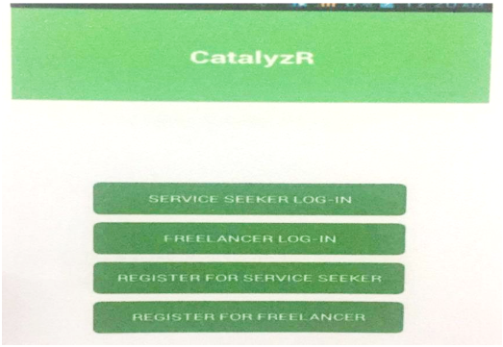

Figure 2: Catalyzer

Catalyzer menu page as shown in figure 2, where you can sign up and register for both

service seeker and freelancer.

**Raket**

Raket.ph is a search engine for Filipino freelancers. It has a different design that is more suitable to the way Filipinos do business. Clients don’t post projects and wait for bids. Instead, you will put up your own profile and portfolio and wait for it to catch the interest of a customer. Employers will then negotiate with you and if you are successful, you can work on a project immediately.

Figure 3: Raket

**The Raket.ph is equipped by powerful search engine tool to filter Raketeers (Job Seeker) for the user’s specific project. As a result, the seekers get the best out of their inquiries and is constantly developed.**

**OnlineJobs.ph**

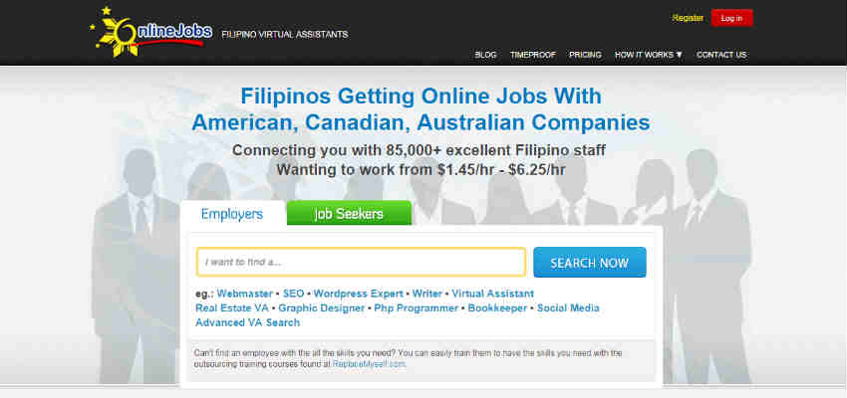OnlineJobs has an extensive bank of Filipino virtual assistants. You will receive a salary, either for a full-time or a part-time position. It doesn’t really matter if you have a college or high school diploma, as long as you can communicate well and deliver, you can get hired.

Figure 4: OnlineJobs

How does OnlineJobs works? 1) Sign up or login to view different fields of works the jobseeker can provide. 2) Find the perfect staff member of your choice hire them by simple mail and negotiate with them regarding the salary, time work. 3) If both parties agreed then the employer will hire the jobseeker.

**Jobstreet**

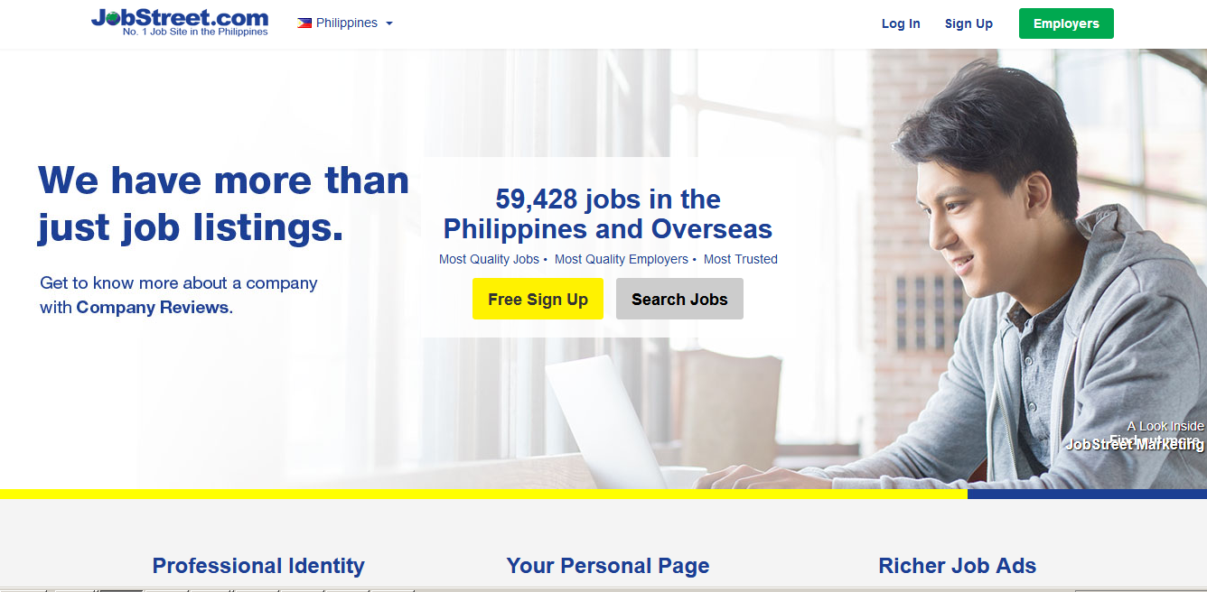Jobstreetis a job portal founded in 1997. Founded in [Malaysia](https://en.wikipedia.org/wiki/Malaysia), it is now Southeast Asia's largest online employment company, according to Forbes. The website features a job matching engine named LiNa for jobseekers and a job posting platform named SiVa for employers.

Figure 5: JobStreet

This platform helps both job seeker and employer by making the job matching easier. The employer may post about a job they are seeking and they may put different criteria like location, specialization and salary which the job seeker may also use for his own ease by using their own search engine.

**Mynimo**

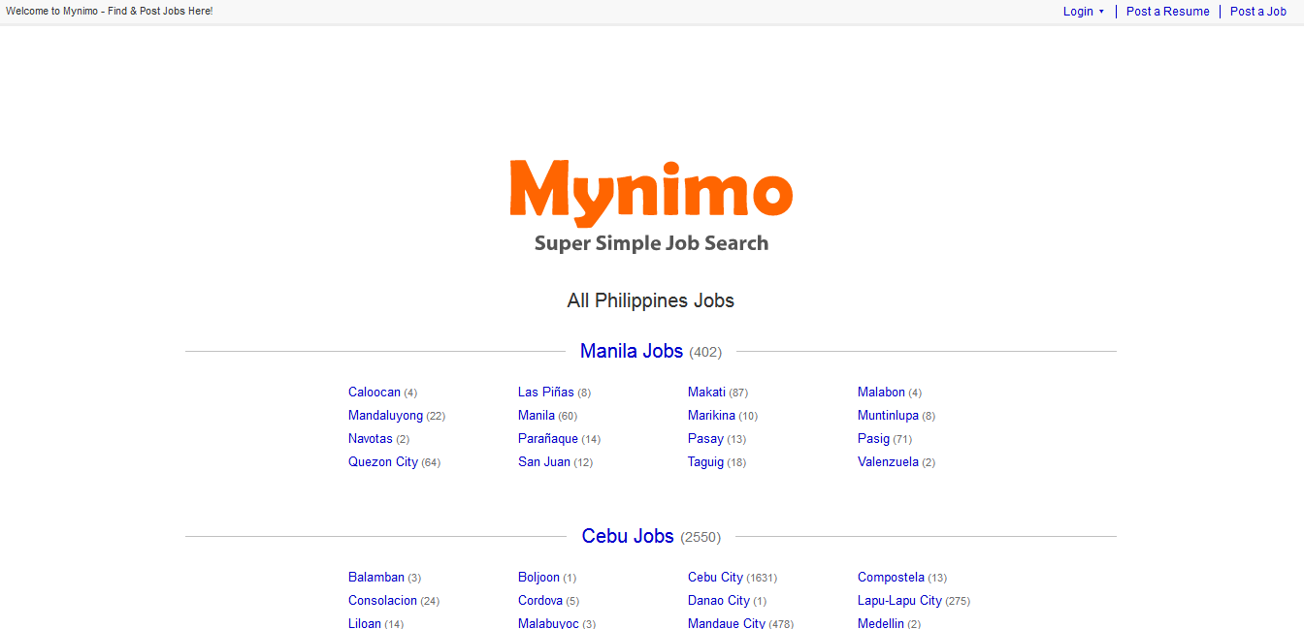Mynimo is committed to connecting job seekers and employers fast by keeping features super simple.

Figure 6: Mynimo

Mynimo categorizes their job for the seeker’s ease of access. Mynimo works by: 1) companies post job that will be seen by job seekers based on their location choose. 2) Choose from different jobs posted and; 3) Apply using Mynimo’s Quick Apply or Create your own resume and wait for a sms message(s) from the employer.

### **Comparative Matrix / Competitor’s Analysis**

The comparative matrix is the checklist of comparison between PassersMate and other related existing systems. It assesses certain features that may or may not be accomplished by other competitors. The comparison of the related studies is itemized based on the features of the system.

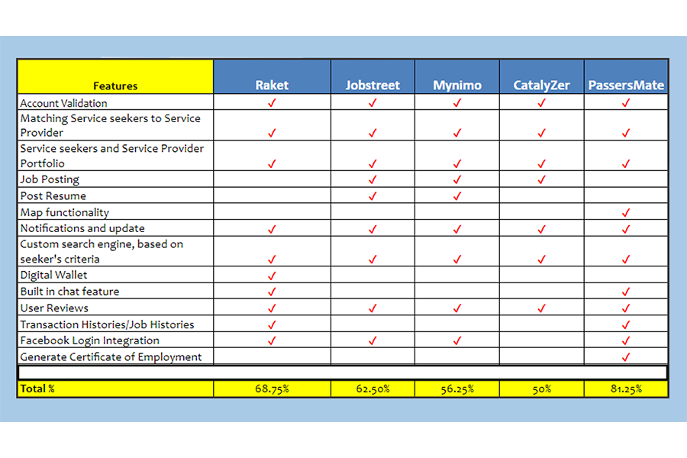TABLE 1

COMPARATIVE MATRIX

The table 1 shows an integrated comparative matrix for the four (4) related studies, namely; Raket, Jobstreet, Mynimo and Catalyzer. Therefore, PassersMate has features that are the same and/or unique with compared to existing system. PassersMate offers the feature of map functionality that enable service seekers to find passer with Google map and generate COE which other competitors do not offer.

## **Legal Bases**

**REPUBLIC ACT NO. 8792**

Former President Joseph E. Estrada of the Philippines signed Republic Act (RA) No. 8792, entitled “**AN ACT PROVIDING FOR THE RECOGNITION AND USE OF ELECTRONIC COMMERCIAL AND NON-COMMERCIAL TRANSACTIONS AND DOCUMENTS”**

**Section 3.** This Act aims to facilitate domestic and international dealings, transactions, arrangements agreements, contracts and exchanges and storage of information through the utilization of electronic, optical and similar medium, mode, instrumentality and technology to recognize the authenticity and reliability of electronic documents related to such activities and to promote the universal use of electronic transaction in the government and general public.

**Section 24.** Choice of Security Methods. - Subject to applicable laws and /or rules and guidelines promulgated by the Department of Trade and Industry with other appropriate government agencies, parties to any electronic transaction shall be free to determine the type of level of electronic data message and electronic document security needed, and to select and use or implement appropriate technological methods that suit their need.

**Section 32.** Obligation of Confidentiality*.* - Except for the purposes authorized under this Act, any person who obtained access to any electronic key, electronic data message or electronic document, book, register, correspondence, information, or other material pursuant to any powers conferred under this Act, shall not convey to or share the same with any other person.

**REPUBLIC ACT NO. 7796**

Former president Fidel V. Ramos of the Philippines signed Republic Act No. 7796, entitled, **“Technical Educational and Skills Development Act of 1994” or the “TESDA Act of 1994”.**

**SECTION 2.** Declaration of Policy. It is hereby declared the policy of the State to provide relevant, accessible, high quality and efficient technical education and skills development in support of the development of high quality Filipino middle-level manpower responsive to and in accordance with Philippine development goals and priorities. The State shall encourage active participation of various concerned sectors, particularly private enterprises, being direct participants in and immediate beneficiaries of a trained and skilled work force, in providing technical education and skills development opportunities.

**Labor Code of the Philippines: PRESIDENTIAL DECREE NO. 442**

A DECREE INSTITUTING A LABOR CODE THEREBY REVISING AND CONSOLIDATING LABOR AND SOCIAL LAWS TO AFFORD PROTECTION TO LABOR, PROMOTE EMPLOYMENT AND HUMAN RESOURCES DEVELOPMENT AND INSURE INDUSTRIAL PEACE BASED ON SOCIAL JUSTICE

**Art. 139. Minimum employable age.**

a. No child below fifteen (15) years of age shall be employed, except when he works directly under the sole responsibility of his parents or guardian, and his employment does not in any way interfere with his schooling.

b. Any person between fifteen (15) and eighteen (18) years of age may be employed for such number of hours and such periods of the day as determined by the Secretary of Labor and Employment in appropriate regulations.

c. The foregoing provisions shall in no case allow the employment of a person below eighteen (18) years of age in an undertaking which is hazardous or deleterious in nature as determined by the Secretary of Labor and Employment.

**Section 10, Rule XIV, Book V, of the Omnibus Rules Implementing the Labor Code of the Philippines provides:**

SECTION 6. Certification of employment. — A dismissed worker shall be entitled to receive, or request, a certificate from the employer specifying the dates of his engagement and termination of his employment and the type or types of work on which he is employed.”

# **CHAPTER III**

# **RESEARCH METHODOLOGY**

## **Software Engineering Methodology**

The Agile Software Development refers to a group of software development methodologies based on iterative development, where requirements and solutions evolve through collaboration between self-organizing cross-functional teams. [Agile development](https://www.cprime.com/2016/03/what-is-agile-product-development/) refers to any development process that is aligned with the concepts of the Agile Manifesto.

The proponents will use scrum as a framework for managing software development. In Scrum, features are written from the perspective of the end user. This framework focuses on making the project adapt changes and work iteratively that gives short and realistic part of the project according to the schedule of each component. The Scrum master keeps the team on focus with the schedules and set up meetings in order to see the progress of the project.

The following reasons are as to why this methodology would be beneficial in the web development industry:

* Applying Scrum in development can lead to reducing the cost of production.
* Scrum methodology enables projects where the business requirements documentation is hard to quantify to be successfully developed.
* Fast moving, cutting edge developments can be quickly coded and tested using this method, as a mistake can be easily rectified.
* Like any other agile methodology, this is also iterative in nature. It requires continuous feedback from the user.
* Daily meetings make it possible to measure individual productivity. This leads to the improvement in the productivity of each of the team members.
* Issues are identified well in advance through the daily meetings and hence can be resolved in speedily
* It is easier to deliver a quality product in a scheduled time.

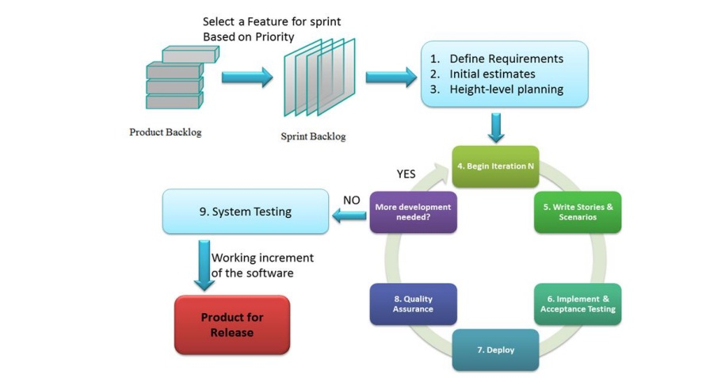

Figure 7: Agile Scrum Methodology

## **Planning or Conception-Initiation Phase**

The initiation phase shows how the system was planned that is composed of the Business Model Canvas, Program Workflow, Validation Board, Gantt Charts and Functional Decomposition Diagram.

### **Business Model Canvas**

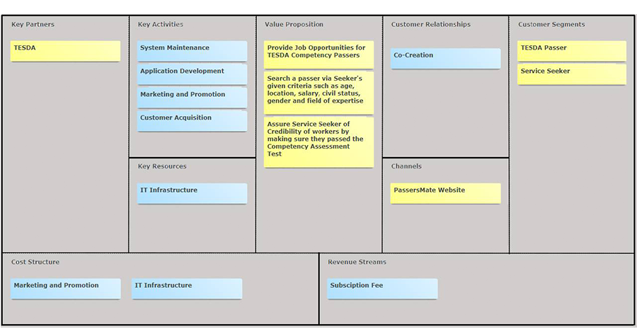The Business Model Canvas is a business tool used to visualize all the building blocks of starting a business, including customers, route to market, value proposition and finance.

Figure 8: Business Model Canvas

**Figure 8: Business Model Canvas**

### **Program Workflow**

Workflow is the series of activities that are necessary to complete a task. In the context of the study of PassersMate, these are the sequence of actions or tasks that are related to the business process.

In Figure 9, the program workflow shows the interaction of PassersMate to the passer and service seeker. The passer and service seeker create an account; PassersMate screens and background check the passer and service seeker’s registration. The users will get notified if their account is approved or rejected by the admin. If approved, they can start managing their portfolio. The service seeker can search a passer according to their given criteria. After that, service seeker can choose passer by viewing their profile and starts to offer a job and get notified if their job offered is approved or rejected by the passer.

Assume that the passer accepts the job offered by the service seeker. They can have a negotiation by using our built-in chat feature. After agreement, the service seeker will hire the passer. The users can make reviews and feedback once the job is done.

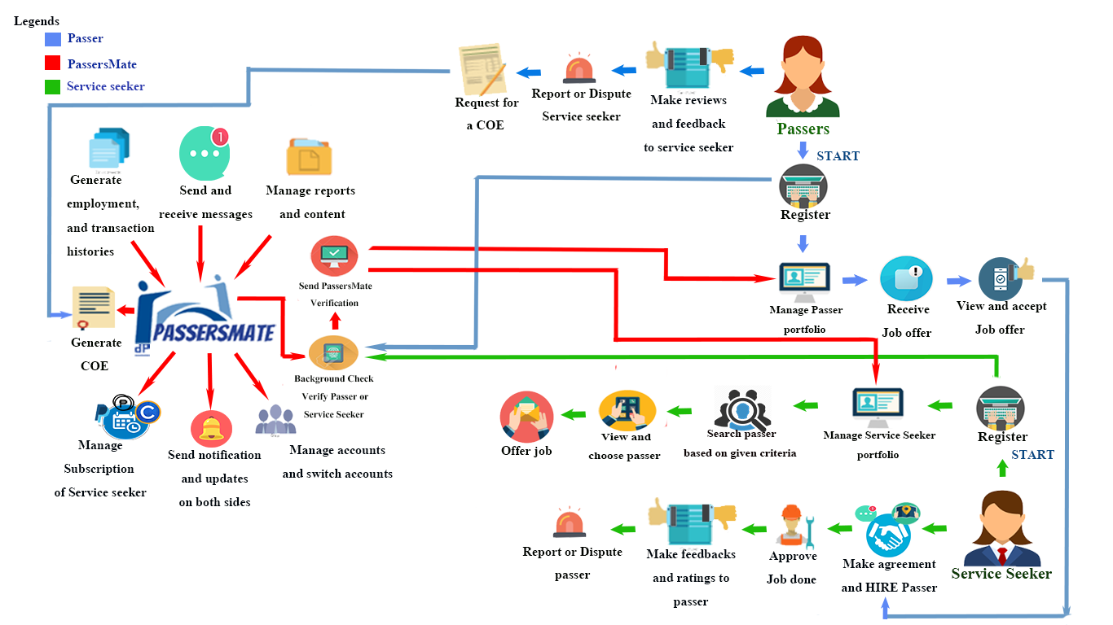

Figure 9: Program Workflow

The passer can request a Certificate of Employment according to his employment histories that happens in PassersMate Website and the PassersMate will generate the requested COE. In an event where a passer is violated in any way possible, he or she may file a dispute against the service seeker and vice versa. The PassersMate will make sure the fairness of both sides. If the service seeker will not respond after 1 week then the PassersMate will act and report it to DOLE.

### **Validation Board**

The proponents used the validation board to validate the assumed problem for the target customers of the system. Validation Board is a tool that is used by the proponents to test if the system is acceptable by the TESDA Passers and Service Seekers.

Table 2

CUSTOMER VALIDATION STAGE 1

|  |  |  |
| --- | --- | --- |
| Startup Idea: PassersMate: An Online Job Marketplace for Technical and Vocational Skills | | |
| Stage: 1 – Problem Validation | | |
| Experiment | 1 | 2 |
| Customer | Service Seeker | Passer |
| Problem | * \*Difficulty in finding possible worker * \*Not enough Resources or acquaintance spread the news about the seeking of worker * \*Issue about if the worker has idea on the job * \*Lack of workers for the job to be finished sooner than later * \*Find worker base on seeker’s criteria | * \*Difficulty on finding a service seeker who wants to hire him/her * \*Difficulty on spreading the news about his skills acquired so Service Seeker may hire him * \*Fear for his/her own safety and security |
| Solution |  |  |
| Riskiest Assumption | Problem Exist | Problem Exist |
| Success Criteria | 86 % using personal interview and survey | 100% using personal interview and survey |
| Results & Discussions | 13/15 = 86 % VALID | 15/15 = 100% Valid |
| Learning | 13 out of 15 stated that they wanted to hire someone with the ability, knowledge and experience about a certain job they seek. | 15 out of 15 stated that they have hard time finding someone seeking the field they have studied and a service seeker which is trusted |

Table 3

CUSTOMER VALIDATION STAGE 2

|  |  |  |
| --- | --- | --- |
| Startup Idea: PassersMate: An Online Job Marketplace for Technical and Vocational Skills | | |
| Stage: 2 – Pre-Sell using Landing Page | | |
| Experiment | 1 | 2 |
| Customer | Service Seeker | Passer |
| Problem | * \*Difficulty in finding possible worker * \*Not enough Resources or acquaintance spread the news about the seeking of worker * \*Issue about if the worker has idea on the job * \*Lack of workers for the job to be finished sooner than later * \*Find worker base on seeker’s criteria | * \*Difficulty on finding a service seeker who wants to hire him/her * \*Difficulty on spreading the news about his skills acquired so Service Seeker may hire him * \*Fear for his/her own safety and security |
| Solution | * Service Seeker-to-Passer matching base on Service Seeker’s criteria * Background-Checking on Passer | * Passer’s Portfolio will be shown to Service Seeker base on its’ corresponding field of work needed * Background-Checking on Service Seeker |
| Riskiest Assumption | Problem Exist | Problem Exist |
| Success Criteria | 73 % using personal interview and survey | 100% using personal interview and survey |
| Results & Discussions | 15/15 = 100% VALID  (persevere) | 15/15 = 100% Valid  (persevere) |
| Learning | 15 out of 15 stated that they wanted to hire someone with the ability, knowledge and experience about a certain job they seek. | 15 out of 15 stated that they have hard time finding job opportunities that match with their skills. |

In table 3, Customer Validation Board shows the stage 2. The proponents used the Landing Page of PassersMate, to gather information during the stage 2 validation.

### **Gantt Chart**

A Gantt chart is a visual representation of a project schedule. It is commonly used in project management, is one of the most popular and useful ways of showing activities (tasks or events) displayed against time.

### 

Figure 10: Gantt Chart December-March



Figure 11: Gantt Chart June-October

### **Functional Decomposition Diagrams**

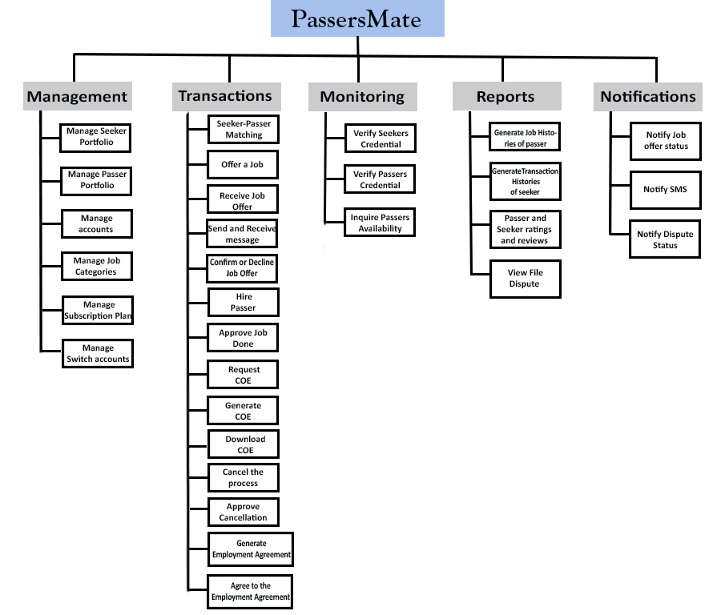Functional Decomposition Diagram (FDD) is a tool used by system analysts to model business related functions in a hierarchical point of view. It decomposes and organizes function from a top-level to a lower-level process where it was translated into program modules during the development of the platform. This section describes the users of the system in a functional level which further advances the comprehension of the proponents, readers and possibly future researchers that may improve the current system.

Figure 12: Functional Decomposition Diagram-Web

## **Analysis-Design Phase**

The design phase shows how the system was analyzed that consists of the Use Case Diagrams, Storyboard, Database Design and Network Design.

### **Use Case Diagrams**

A use case diagram describes how users perform tasks on a system. It outlines how the system responds to the request of a certain actor. It shows the steps performed by an actor and how these processes relate to each other.

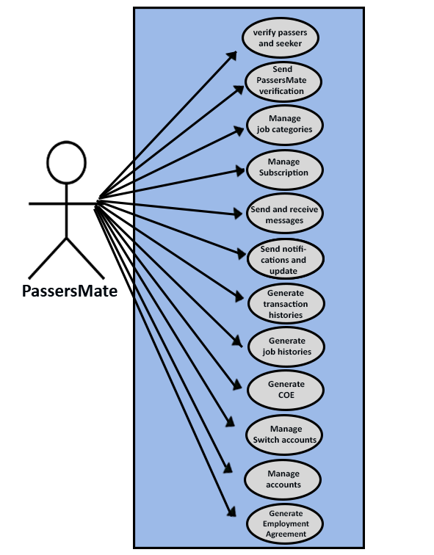

Figure 13: Use Case Diagram-PassersMate

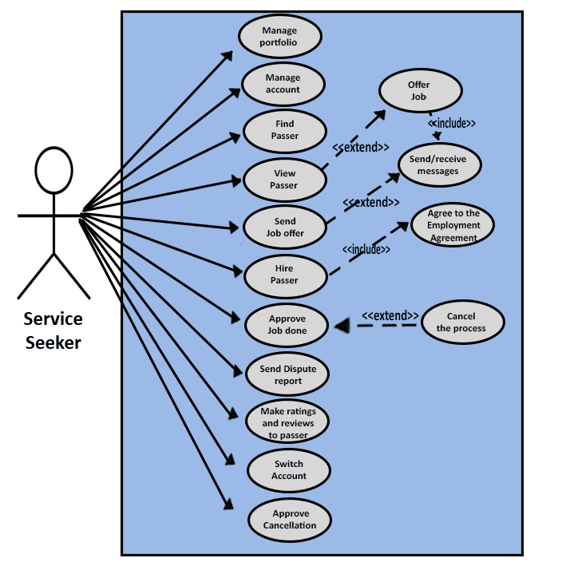Figure 13 shows that PassersMate acts as the admin. PassersMate can manage the accounts of passers and service seekers. The admin is responsible for the verifying of the passers and service seekers. Manage job categories, subscription of service seeker, send and receive messages, send notifications and update to the passers and service seekers. Generate transaction histories, job histories, employment agreement and also generates a COE that is requested by the passer.; lastly the PassersMate manage the switch accounts.

Figure 14: Use Case Diagram-Service Seeker

Figure 14 shows the service seeker can manage her account and portfolio. The service seeker can find and view passer and offers a job, aside from offering job, the service seeker can negotiate and have agreements with the passer by sending or receive messages. The service seeker can hire passer only if she will agree to the terms and condition of employment agreement. Once the service seeker approve that the job is successfully done by the passer, she can make ratings and reviews to the passer. In an event where a service seeker is violated in any way possible, she may file a dispute against the passer. The service seeker can cancel the process and approve cancellation.

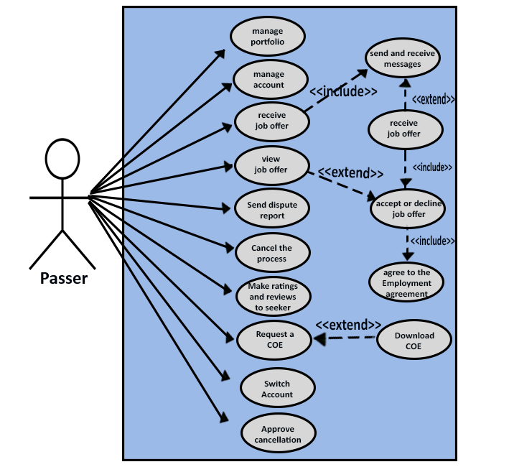Service seeker can also switch into passer by submitting Certificate of Competency Assessment.

Figure 15: Use Case Diagram- Passer

Figure 15 shows the passer process. The passer can manage his account and portfolio. Passer receives job offer from the service seeker; He can view and accept or decline the job offered by the service seeker. The passer can negotiate with the service seeker by sending or receive messages. The passer will be hired once the negotiation is done and if both of them agrees to the employment agreement. Passer can request for a COE only if the service seeker approves that he successfully fulfilled the job. He can also download the COE. The passer can cancel the process and approve cancellation. Passer can also switch into service seeker.

### **Storyboard**

In software development, a storyboard is used to visualize or explain the flow of the elements of a system during the design phase.

Figure 16: Storyboard-Landing Page

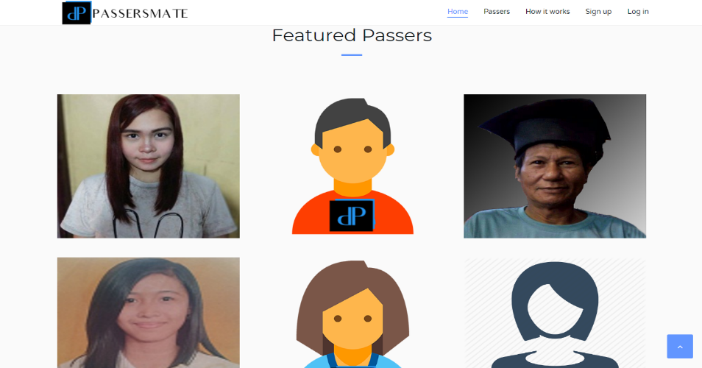Figure 16 shows the homepage of PassersMate, where there is a “Search” button which is a link to the desired job categories of service seeker.

Figure 17: Featured Passers

Figure 17 shows the featured passers that successfully performed their job.

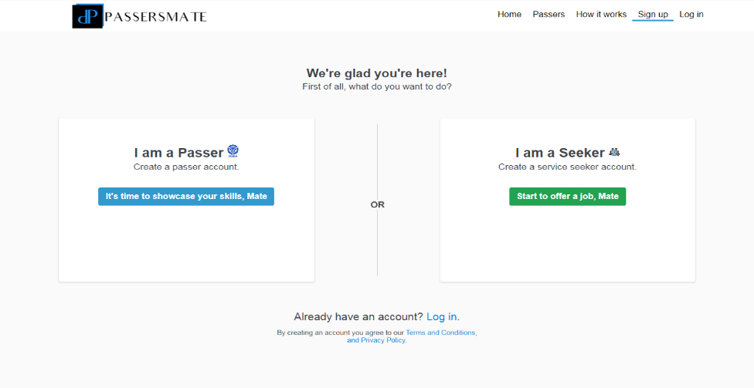

Figure 18: Registration Page-Passer or Seeker

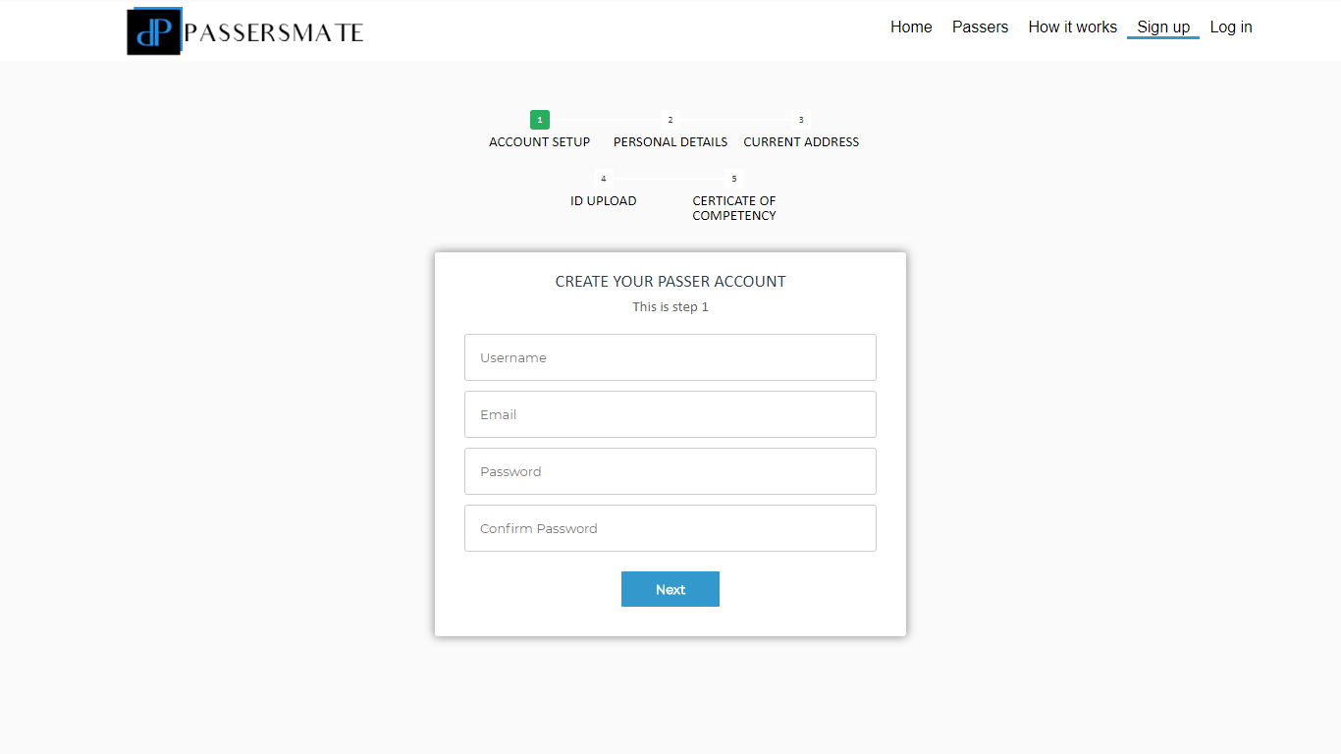Figure 18 shows the registration page which the user will choose their account if he or she is a passer or service seeker.

Figure 19: Passer’s Registration Page

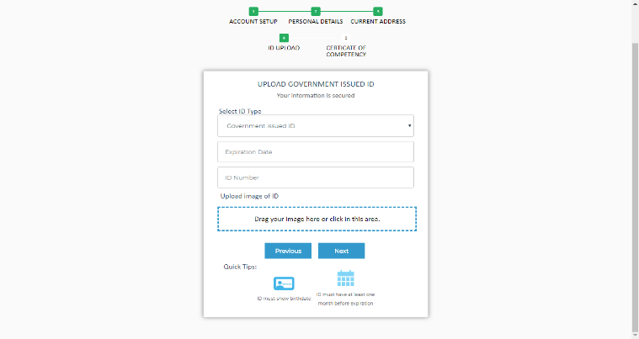

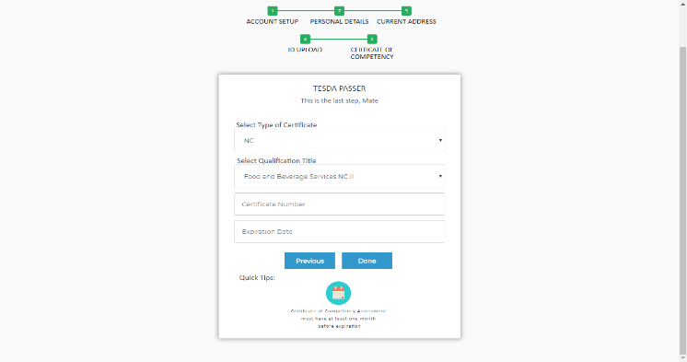Figure 20: Passer’s Registration Page- Government Issued ID

Figure 21: Passer’s Registration Page- Certificate of Competency Assessment

### C:\Users\MarveeLoper\Desktop\PassersMate\Story Board\st5.png

Figure 22: Login Page

Figure 22 shows the Login Page of users. They can login using their fb accounts or Gmail accounts.

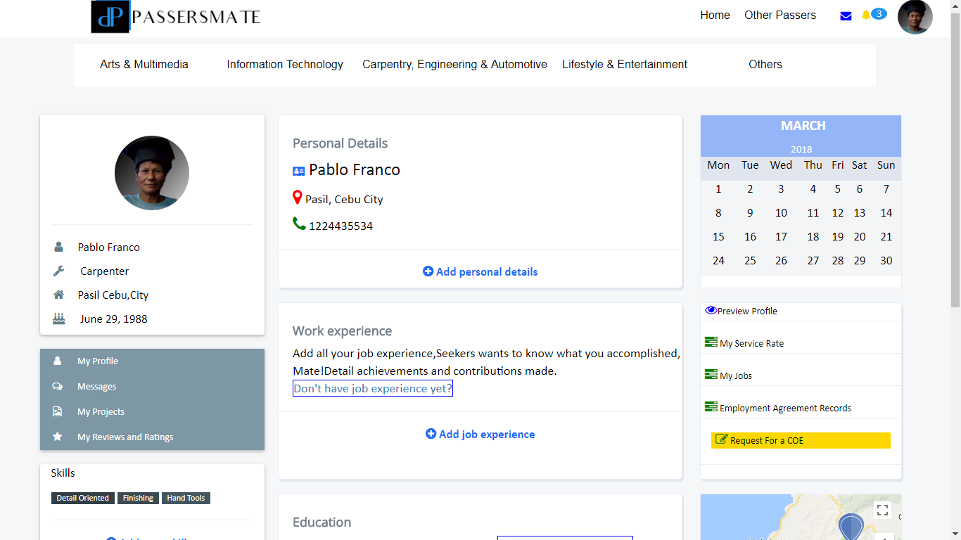

Figure 23: Passer’s Dashboard

Figure 23 shows the passer’s dashboard of PassersMate. Passer can add his work experience, personal details, can upload photos of his or her projects, can preview his profile, view his job histories and etc.

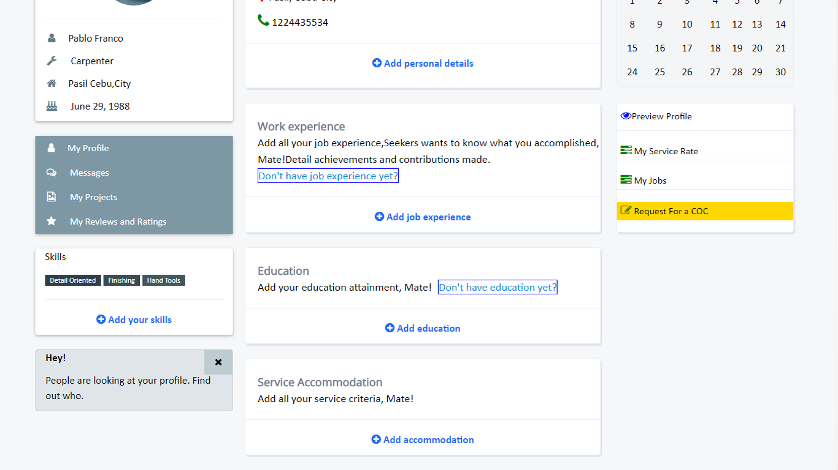

Figure 24: Passer’s Dashboard-2

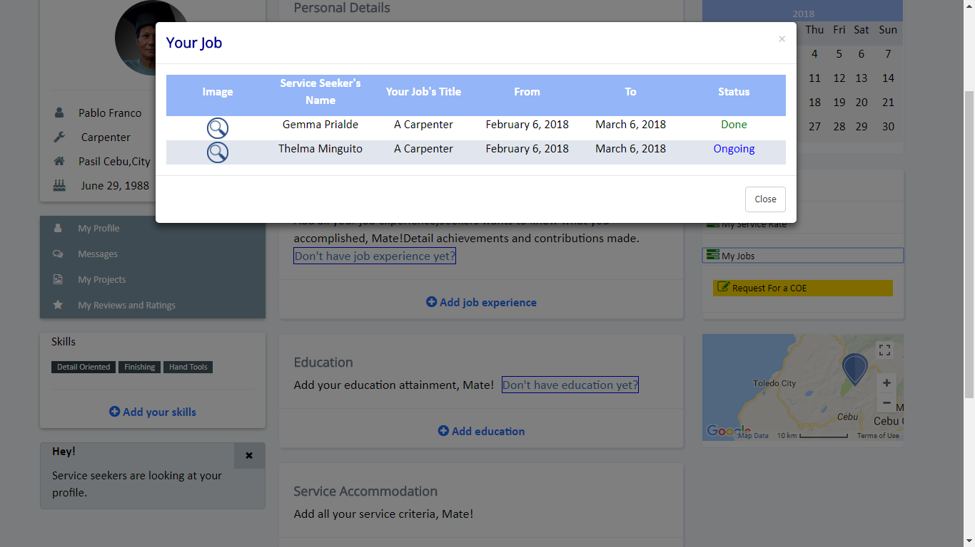

Figure 25: Passer’s Dashboard- Job Records

Figure 25 shows the job records of the passer. This shows the status of the job if it’s done or ongoing.

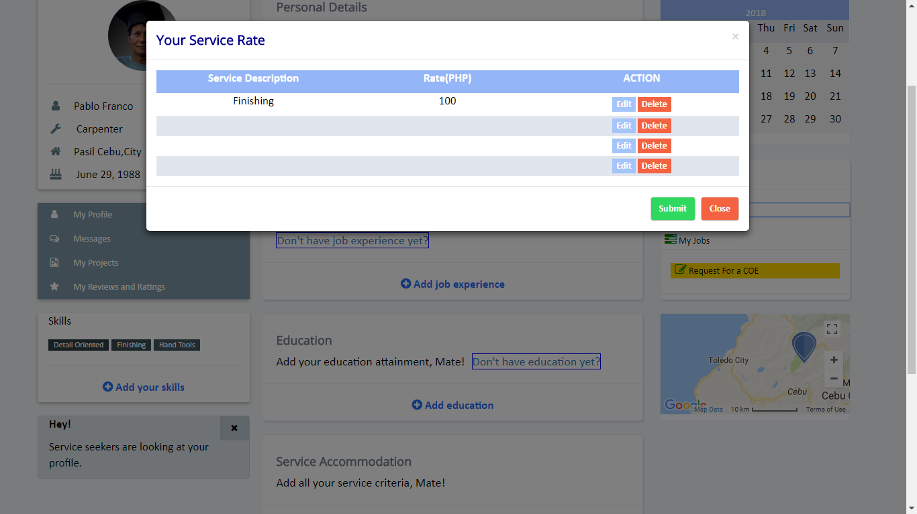

Figure 26: Passer’s Dashboard- Service Rate

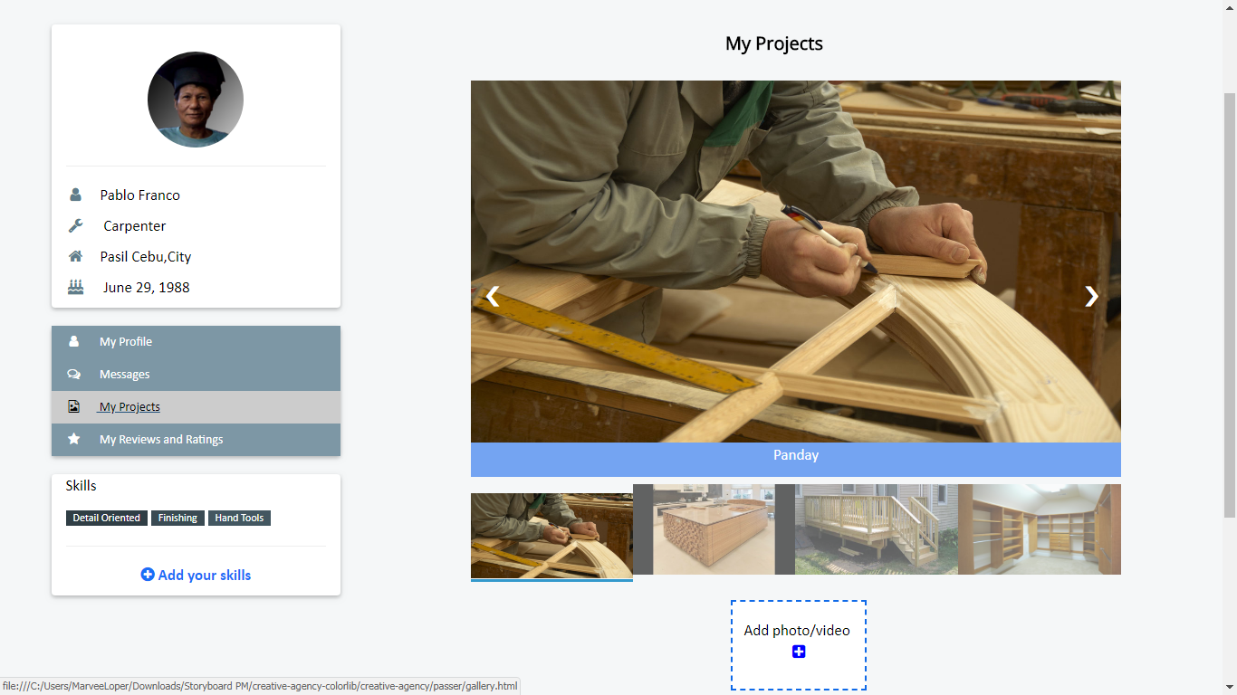Figure 26 shows the service rate of the passer. It lets the passer to add his service description and edit his estimated service rate.

Figure 27: Passer’s Dashboard- My Projects

Figure 27 shows the “My Projects” section of passer, he can upload a photo or video about his done projects.

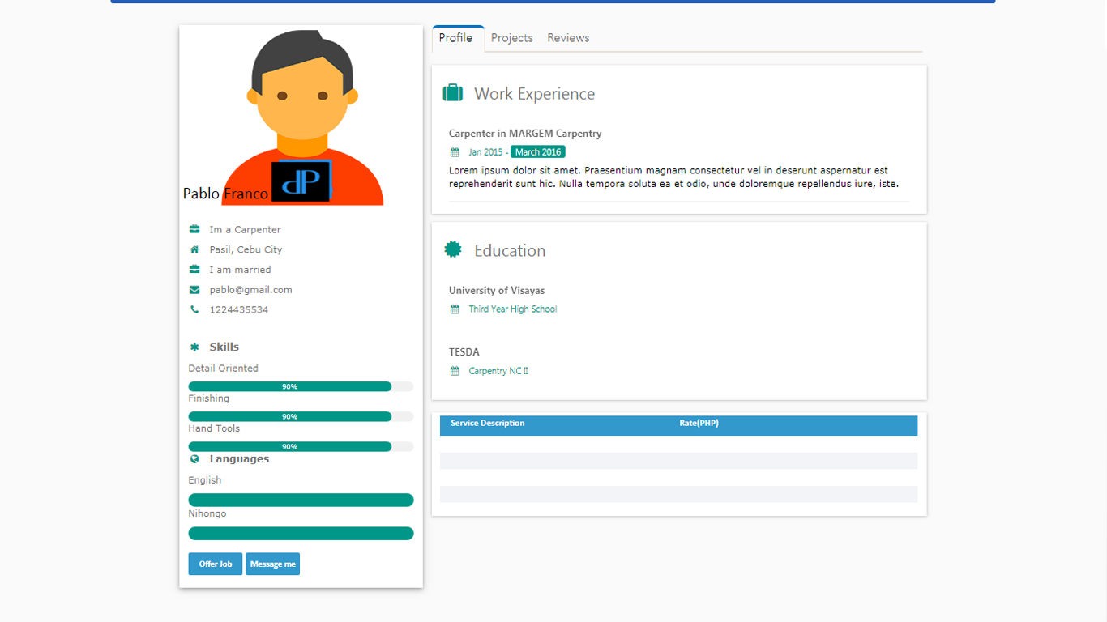

Figure 28: Passer’s Portfolio

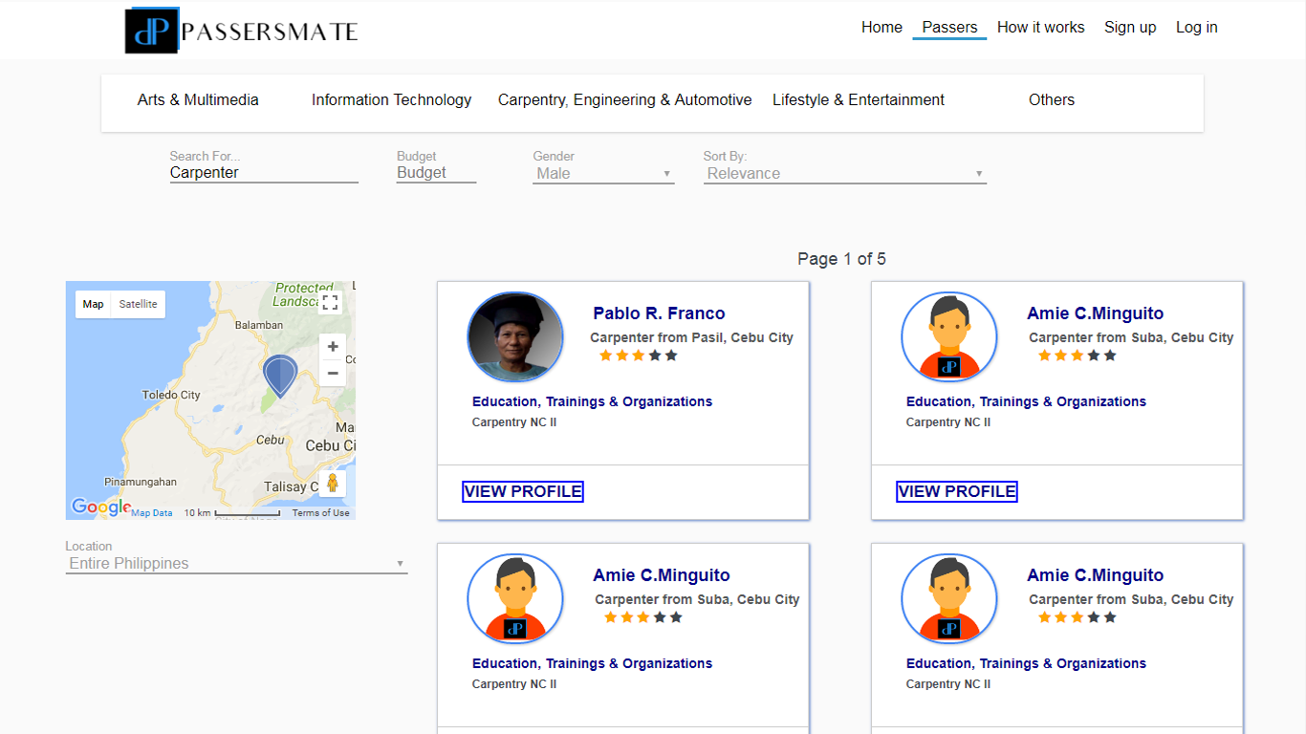Figure 28 shows passers portfolio which the service seeker sees and shows the “offer job” and “message me” button which service seeker can offer a job or message the passer.

Figure 29: PassersMate Search Area

Figure 29 shows the search area which service seekers can search passer based on budget, gender, nearest location and etc. Search area has a map functionality where it’s easy for the service seeker to find passer that near to his/her location.

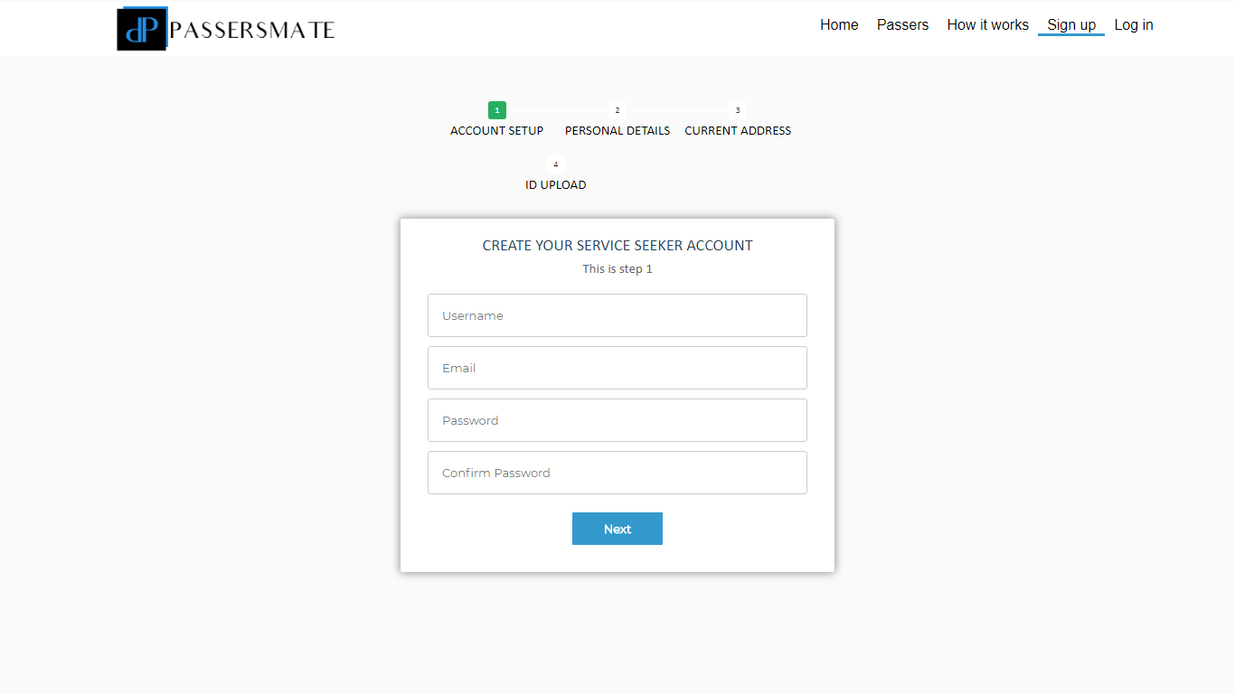

Figure 30: Service Seeker’s Registration Page

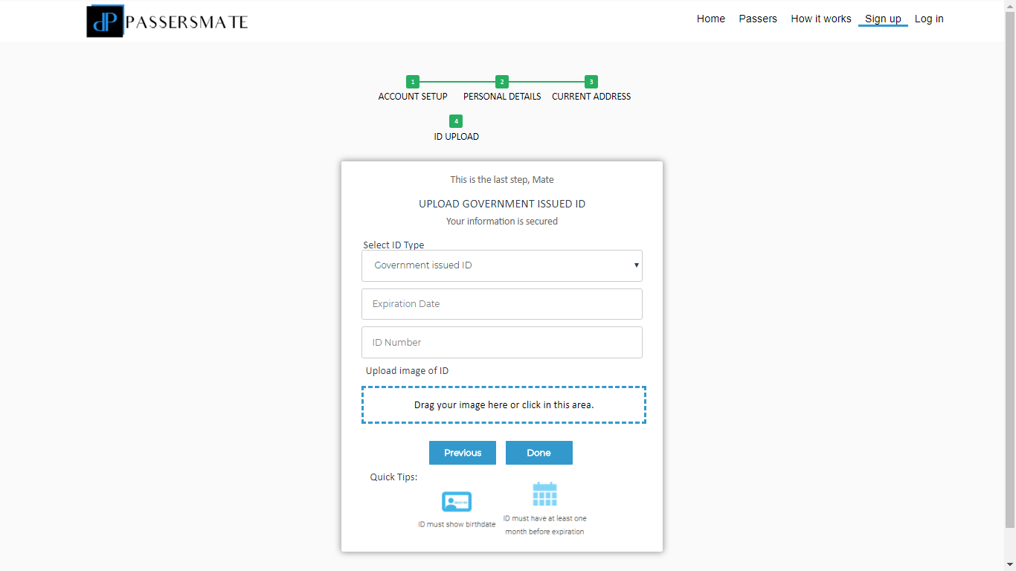

Figure 31: Service Seeker’s Registration Page-Upload Government ID

Figure 31 shows the service seeker’s registration page which they must upload government issued id for security purposes.

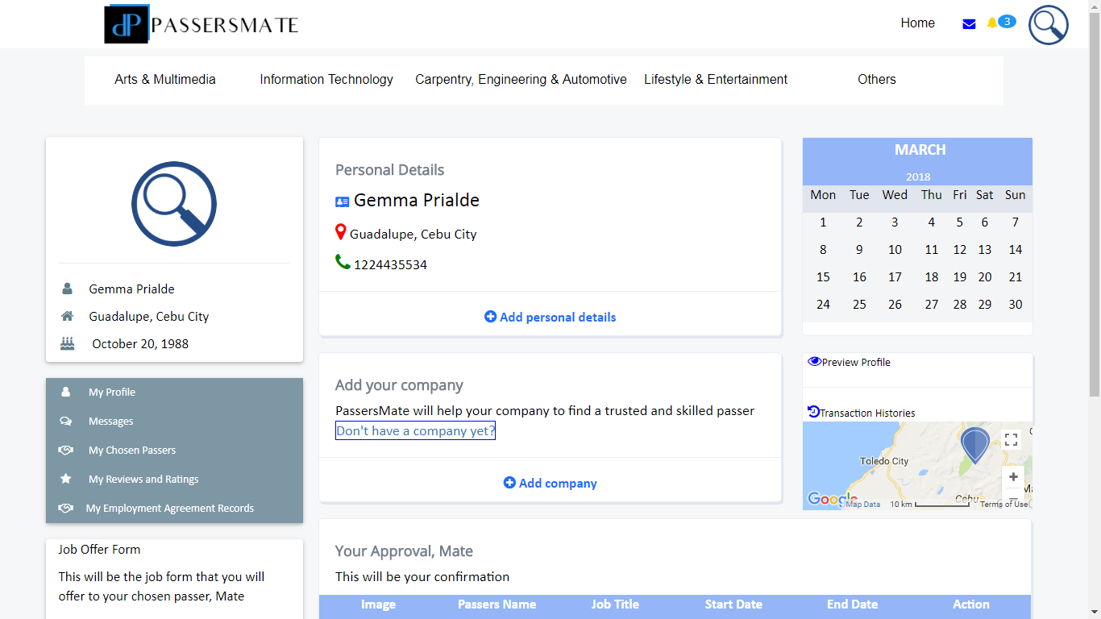

Figure 32: Service Seeker’s Dashboard

Figure 32 shows the service seeker’s dashboard of PassersMate. Service seeker can add her personal details, company, can preview her profile, view her transaction histories and etc.

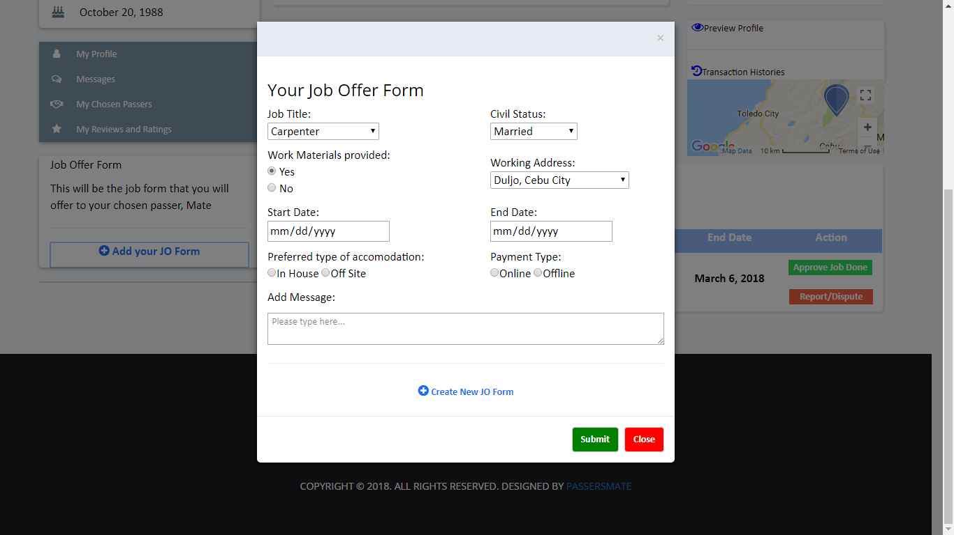

Figure 33: Service Seeker’s Dashboard-Job Offer Form

In this figure, the service seeker’s dashboard has “Add your JO Form” button. Service seeker clicks the button and after that a modal will appear and shows the JO Form. This form will be use if the seeker wants to offer a job to a passer.

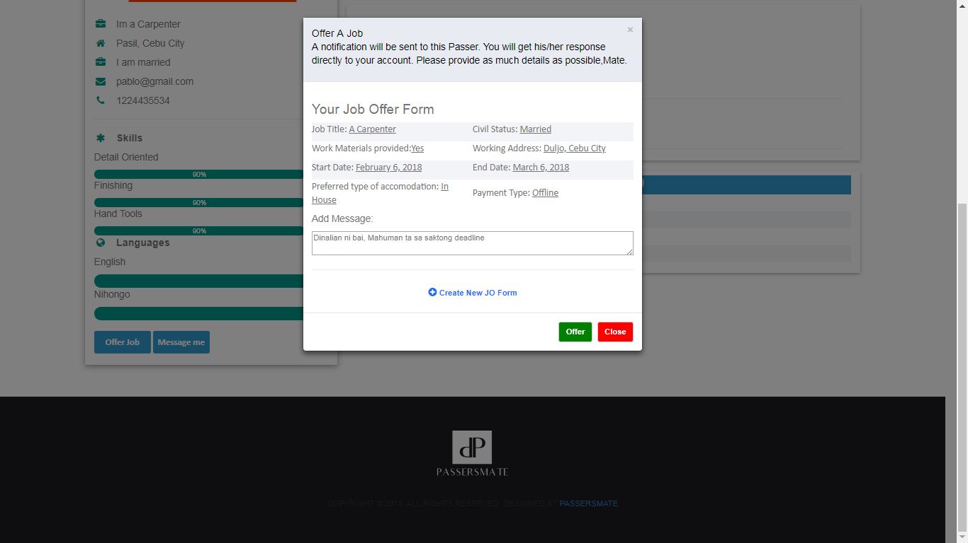

Figure 34: Service Seeker Offers a Job

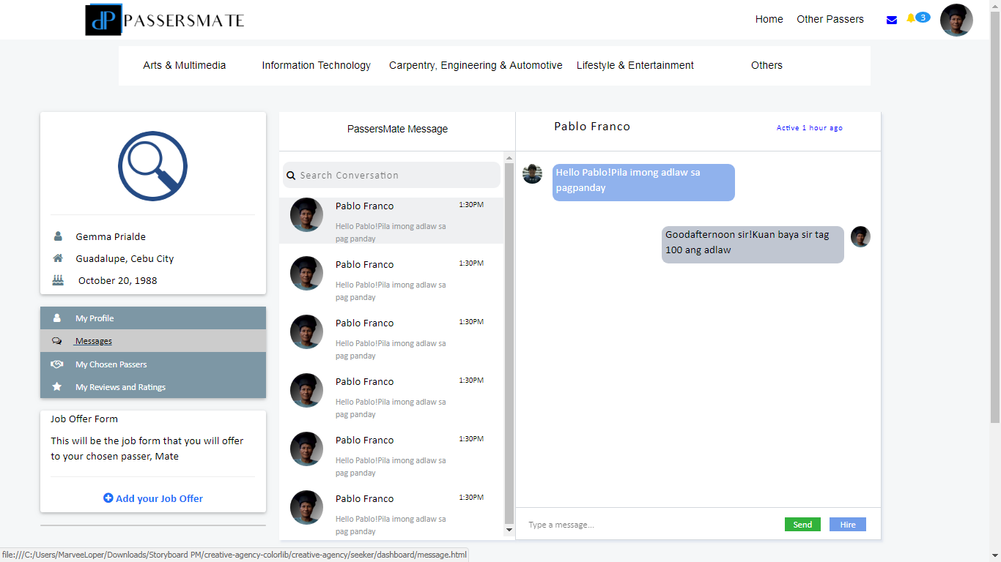The service seeker chooses a passer and view his portfolio. Service seeker clicks the “Offer Job” button and then a modal will appear and shows the JO Form that the service seeker already saves. She can use her default JO form or she can create another one. After the service seeker submits her job offer then a notification will be sent to the passer.

Figure 35: Service Seeker’s Chat Box

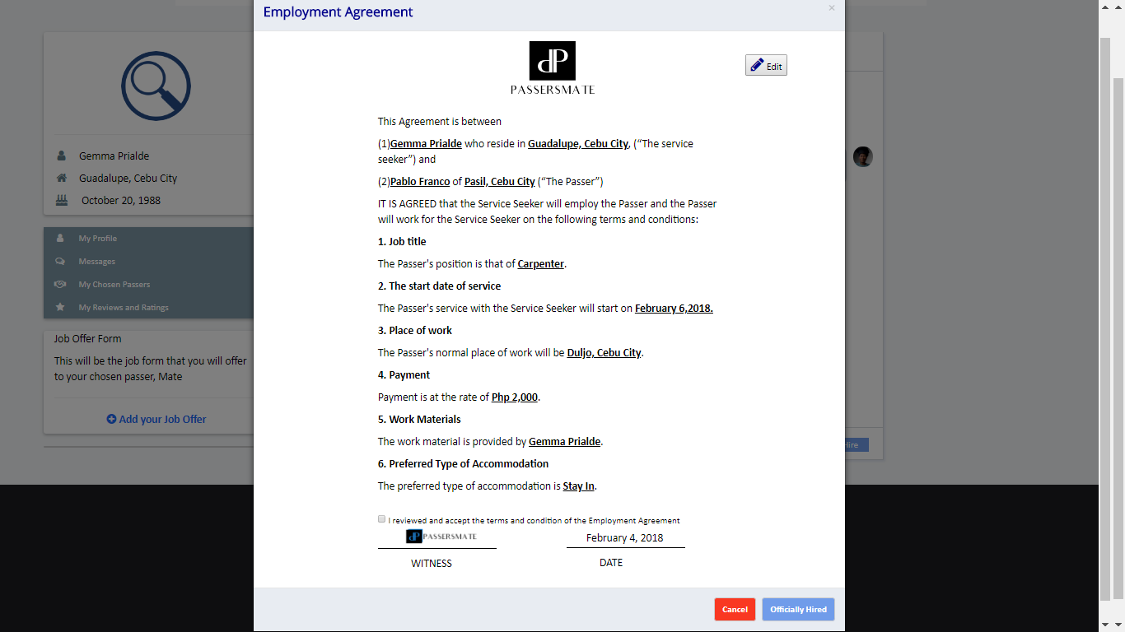Figure 35 shows the built-in chat feature of the PassersMate. Service seeker can message her chosen passer. After the negotiation and agreement, service seeker can hire the passer by clicking the “Hire” button then a notification will be sent to the passer.

Figure 36: PassersMate Confirmation- Employment Agreement

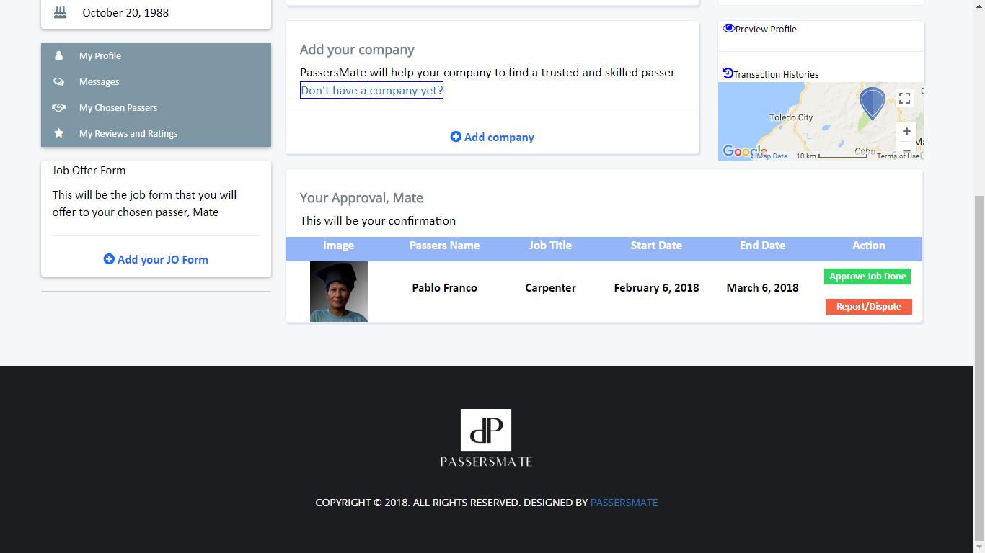Figure 36 shows the generated Employment Agreement of PassersMate. After the Service seeker agrees to the terms and condition and reviews the agreement then she can officially hire the passer then a notification will be sent to the passer

Figure 37: Service Seeker’s Dashboard- Approval Form

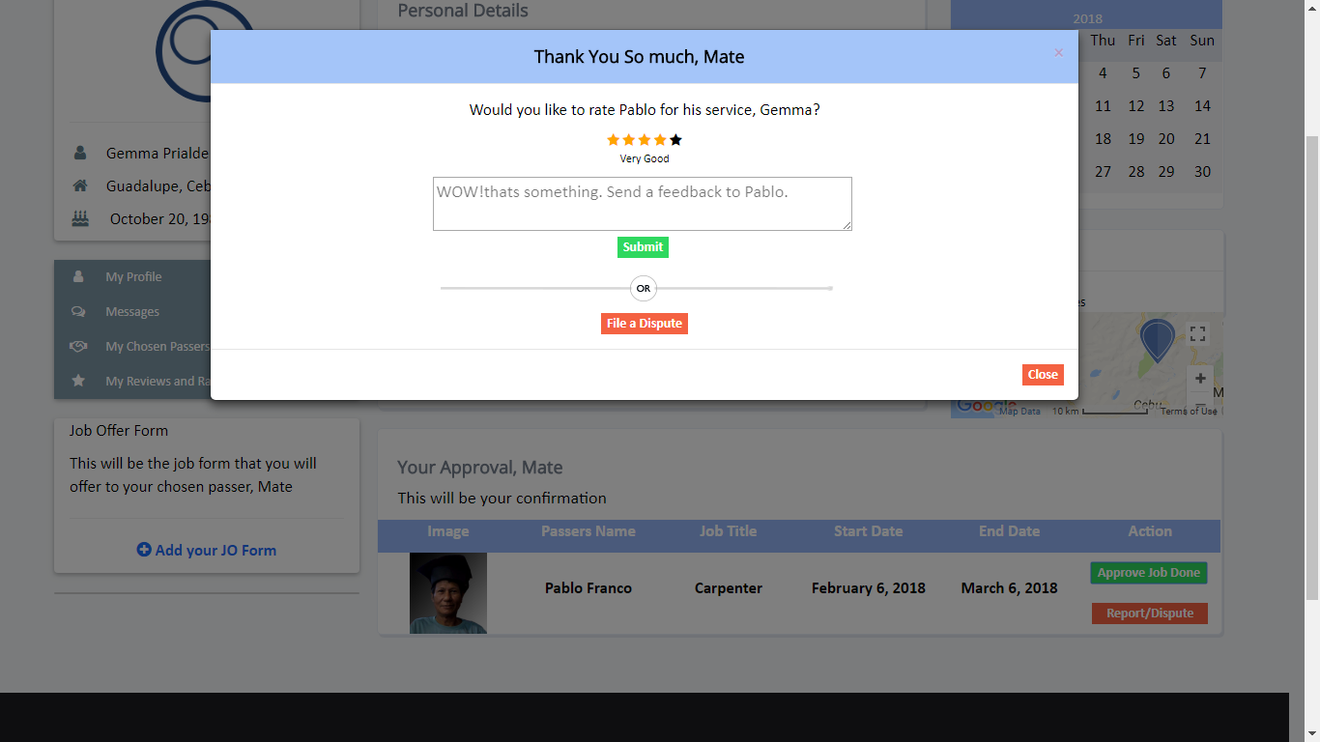Figure 37 shows the approval form of the job. There is “Approve Job Done” button which confirms that the job is done by the passer and also a “Report/Dispute” button which the service seeker files a dispute to the passer.

Figure 38: Reviews and Ratings Section

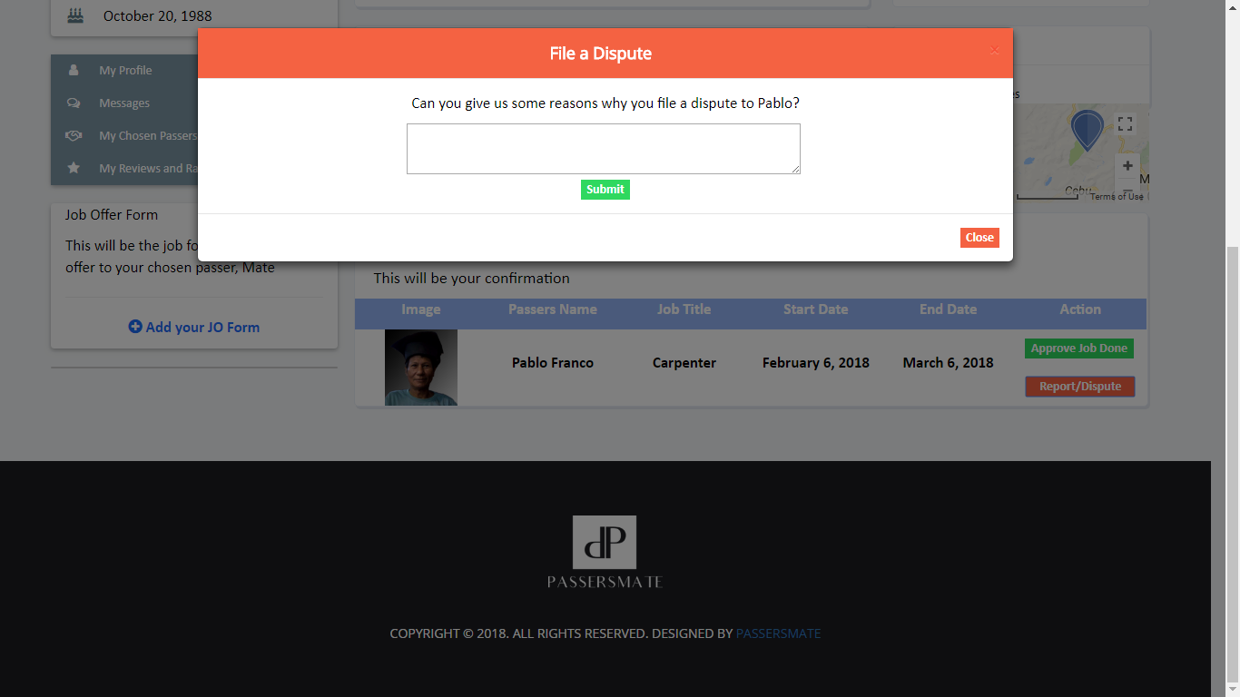Figure 38 shows the reviews and ratings section. PassersMate loves to hear your feedbacks.

Figure 39: PassersMate File a Dispute Form

Figure 39 shows the File a Dispute form which in an event where a passer is violated in any way possible, he or she may file a dispute against the service seeker and vice versa.

**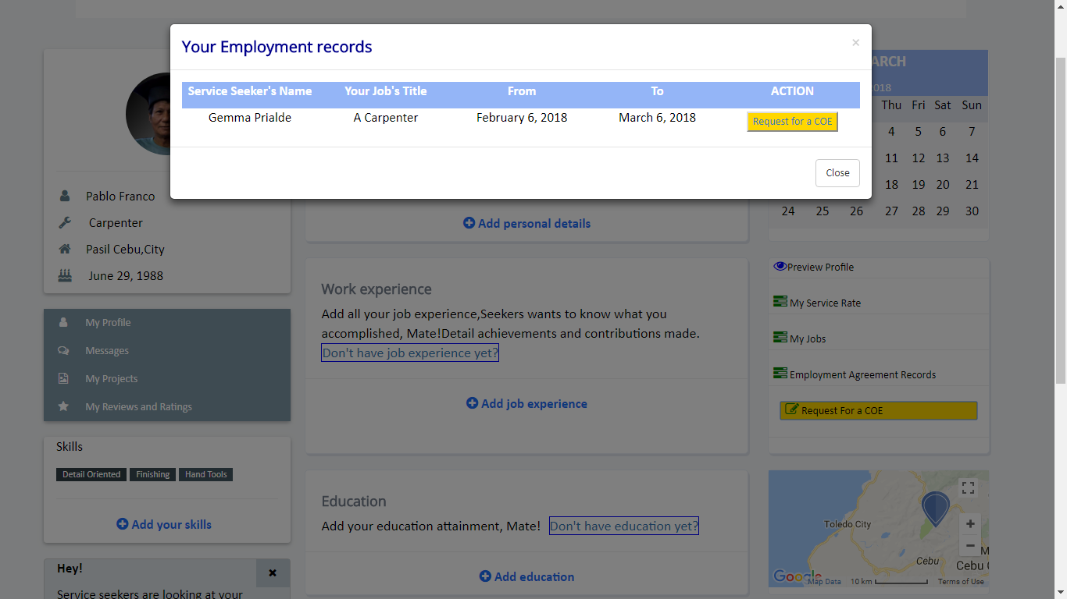**

Figure 40: Request a Certificate of Employment

Figure 40 shows the employment records of passer and she can also request for a COE.

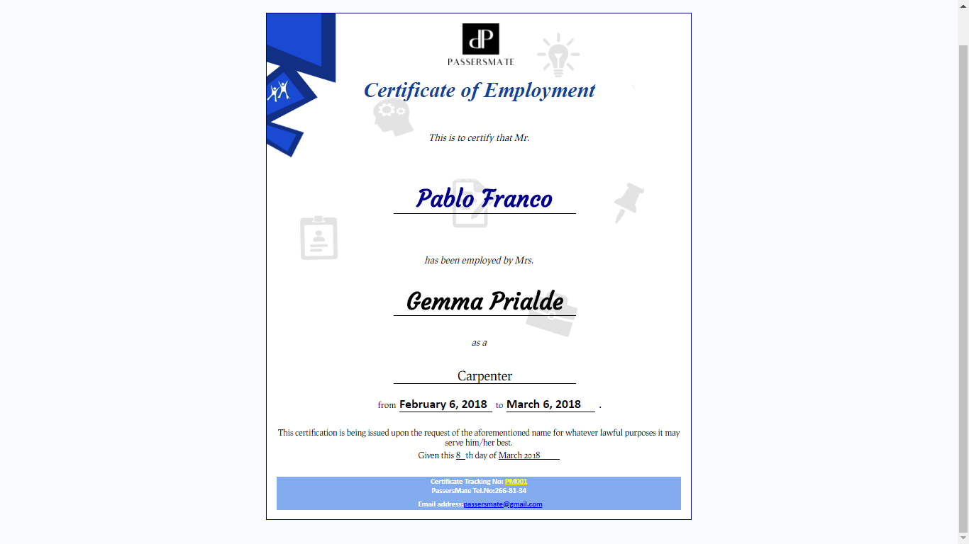

Figure 41: PassersMate COE

Figure 41 shows the generated Certificate of Employment of PassersMate. It has the passer’s name, the service seeker’s name, the job title of the passer, and the specified start and date. It also has a Certificate Tracking No. to avoid any scam and modus.

### **Database Design**

The network design shows how the system was designed. This consists of Entity-Relationship Diagram and Data Dictionary.

### **Entity-Relationship Diagram**

An entity relationship model is an abstract and conceptual representation of data. Entity relationship modelling is a database modelling technique used to produce a semantic data model of a system, often a relational database; and its requirements in a top down fashion. ERD show entities in a database and relationships between tables within the database.

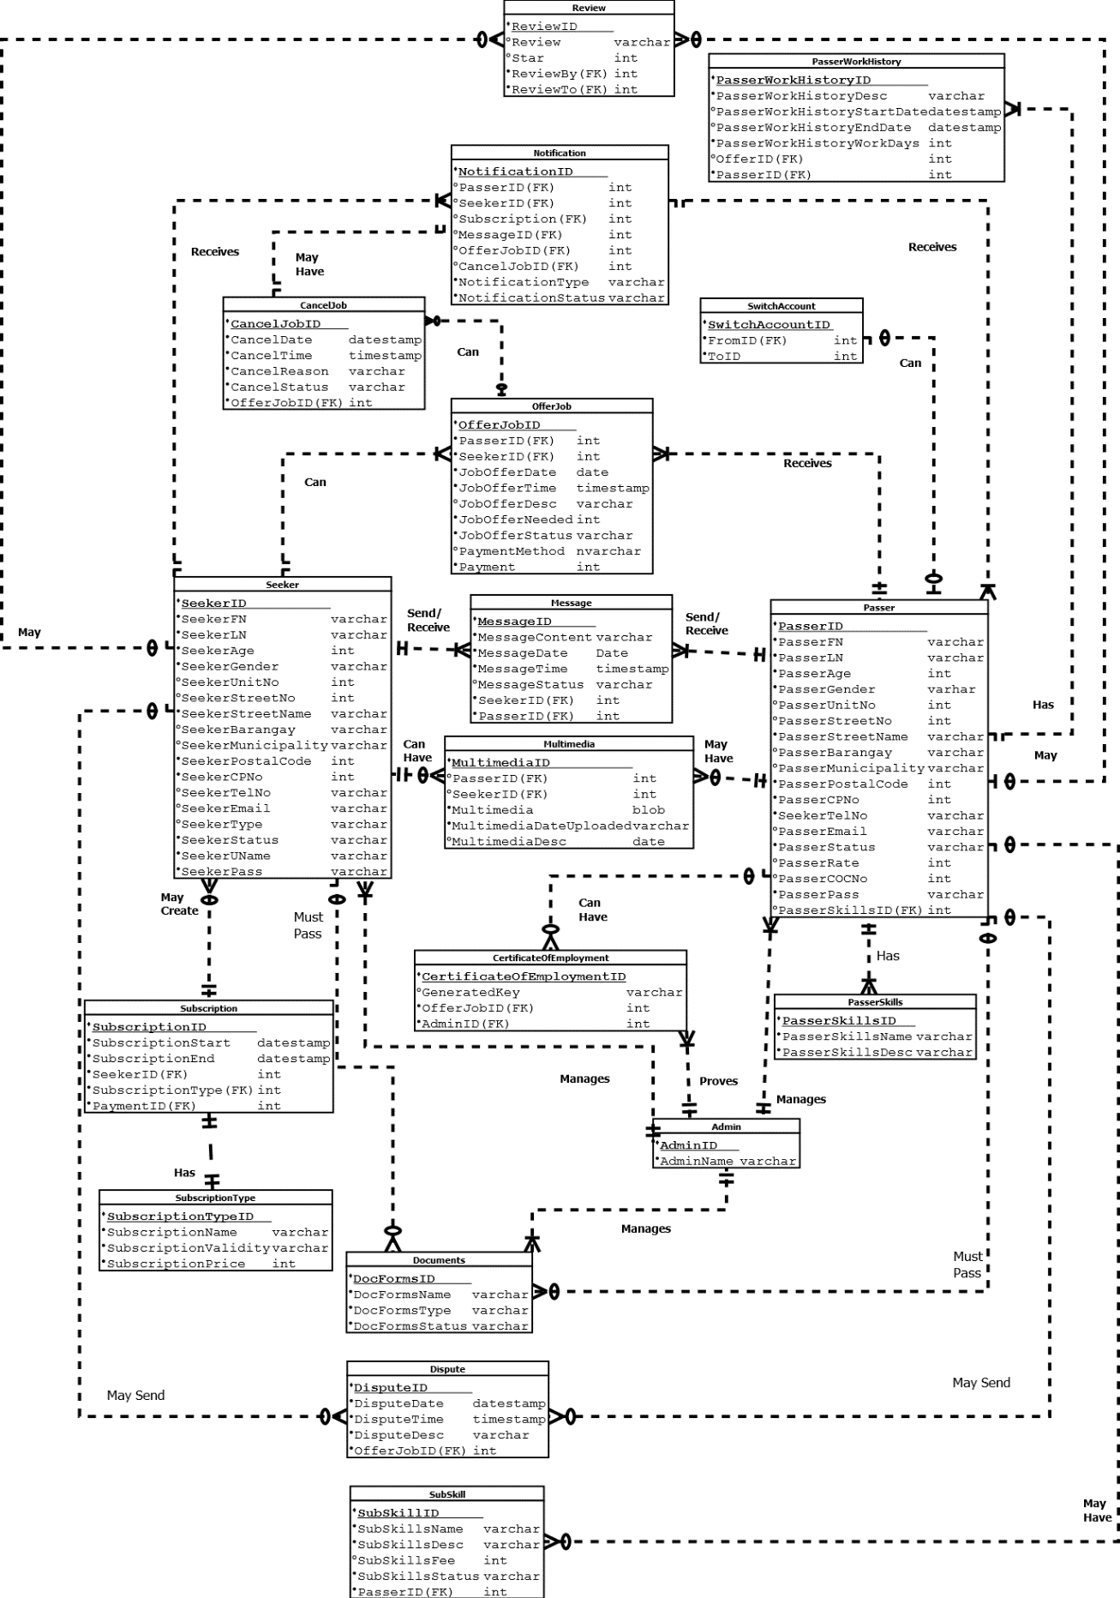

Figure 42: Entity-Relationship Diagram

Figure 42 exhibits that after a service seeker or passer registers, they will still need to pass government certificates (and COC for passers) to be able to use the system. On the other side, the admin manages them and makes action whether to accept or decline the request to be validated and use the system. If validated, the service seeker needs to acquire subscription and if acquired, he/she can now search for the job category that will help them with their doings. As for the passer, he/she will receive a notification that contains the information about the job offered and at the same time, can communicate to the service seeker via chat. If both users agreed to each other’s terms, the service seeker will now fill up the final job offer form which will serve as their employment agreement. After the job has been done, the service seeker can now update the status of the job and can now leave a feedback to passers and vice versa. if something goes wrong, a dispute may be filed which will be thoroughly investigated by the admins after hearing the both sides.

### **Data Dictionary**

The data dictionary represents the repository of information about data such as field name, description, data type with its corresponding length and if it is nullable.

Table 4

DATA DICTIONARY - Seeker

|  |  |  |  |
| --- | --- | --- | --- |
| **Field Name** | **Data Type** | **Description** | **Nullable** |
| SeekerID | Int | Unique primary key with auto generated value | No |
| SeekerUName | Varchar (255) | The address of the member | No |
| SeekerPass | Varchar (255) | The password of the seeker | No |
| SeekerFN | Varchar (255) | The first name of the seeker | No |
| SeekerLN | Varchar (255) | The last name of the seeker | No |
| SeekerAge | Int | The Age of the Seeker | No |
| SeekerGender | Varchar (255) | The gender of the seeker | No |
| SeekerUnitNo | Int | The Unit Number of the seeker | Yes |
| SeekerStreetNo | Int | The Street Number of the seeker | Yes |
| SeekerStreetName | Varchar (255) | The Street Name of the seeker | No |
| SeekerBarangay | Varchar (255) | The Barangay of the seeker | Yes |
| SeekerMunicipality | Varchar (255) | The Municipality of the seeker | Yes |
| SeekerPostalCode | Int | The postal code of the seeker | No |
| SeekerCPNo | Int | The cellphone number of the seeker | No |
| SeekerTelNO | Varchar (255) | The telephone number of the seeker | Yes |
| SeekerType | Varchar (255) | The type of seeker | No |
| SeekerEmail | Varchar (255) | The email of the seeker | Yes |
| SeekerStatus | Varchar (255) | The status of the seeker | No |

Table 5

DATA DICTIONARY - Multimedia

|  |  |  |  |
| --- | --- | --- | --- |
| **Field Name** | **Data Type** | **Description** | **Nullable** |
| SeekerMultimediaID | Int | Unique primary key with auto generated value | No |
| SeekerID | Int | Foreign/reference key which corresponds from Seeker to Multimedia | No |
| PasserID | Int | Foreign/reference key which corresponds from Passer to Multimedia | No |
| Multimedia | BLOB(4mb) | The uploaded file of the seeker | No |
| MultimediaDateUploaded | Datestamp | The date when the multimedia uploaded | No |
| MultimediaDesc | Varchar (255) | The description of the multimedia | Yes |

Table 6

DATA DICTIONARY - Subscription

|  |  |  |  |
| --- | --- | --- | --- |
| **Field Name** | **Data Type** | **Description** | **Nullable** |
| SubscriptionID | Int | Unique primary key with auto generated value | No |
| SeekerID | Int | Foreign/reference key which corresponds from seeker to Subscription | No |
| PaymentID | Int | Foreign/reference key which corresponds from seeker to Subscription | No |
| SubscriptionTypeID | Int | Foreign/reference key which corresponds from subscriptionType to Subscription | No |
| SubscriptionStart | DateStamp | The date when the subscription started | No |
| SubscriptionEnd | DateStamp | The date when the subscription ended | No |

Table 7

DATA DICTIONARY - Message

|  |  |  |  |
| --- | --- | --- | --- |
| **Field Name** | **Data Type** | **Description** | **Nullable** |
| MessageID | Int | Unique primary key with auto generated value | No |
| SeekerID | Int | Foreign/reference key which corresponds from seeker to Message | No |
| PasserID | Int | Foreign/reference key which corresponds from passer to Message | No |
| MessageContent | Varchar (255) | The context of the message | Yes |
| MessageDate | Datestamp | The date on when the message sent | No |
| MessageTime | Timestamp | The time on when the message sent | No |
| MessageStatus | Varchar (255) | The status of the message | No |

Table 8

DATA DICTIONARY - OfferJob

|  |  |  |  |
| --- | --- | --- | --- |
| **Field Name** | **Data Type** | **Description** | **Nullable** |
| OfferJobID | Int | Unique primary key with auto generated value | No |
| SeekerID | Int | Foreign/reference key which corresponds from seeker to OfferJob | No |
| PasserID | Int | Foreign/reference key which corresponds from passer to OfferJob | No |
| JobOfferDate | Datestamp | The Date of the job offer | No |
| JobOfferTime | Timestamp | The time of the job offer | No |
| JobOfferDesc | Varchar (255) | The job offer Descriptions | Yes |
| JobOfferNeeded | Int | The needed workers of the seeker | No |
| JobOfferStatus | Varchar (255) | The status of the job offer | No |
| PaymentMethod | varchar (255) | The method on payment in the Job offer | No |
| Payment | Int | The Payment of the Job Offer | No |

Table 9

DATA DICTIONARY - CancelJob

|  |  |  |  |
| --- | --- | --- | --- |
| **Field Name** | **Data Type** | **Description** | **Nullable** |
| CancelJobID | Int | Unique primary key with auto generated value | No |
| OfferJobID | Int | Foreign/reference key which corresponds from OfferJob to CancelJob | No |
| CancelDate | Datestamp | The Date of the job cancel | No |
| CancelTime | Timestamp | The time of the job cancel | No |
| CancelReason | Varchar (255) | The reason for sending cancel request | No |
| CancelStatus | Varchar (255) | The status of cancel request | No |

Table 10

DATA DICTIONARY - Notification

|  |  |  |  |
| --- | --- | --- | --- |
| **Field Name** | **Data Type** | **Description** | **Nullable** |
| NotificationID | Int | Unique primary key with auto generated value | No |
| SubscriptionID | Int | Foreign/reference key which corresponds from Subscription to Notification | Yes |
| SeekerID | Int | Foreign/reference key which corresponds from seeker to Notification | No |
| PasserID | Int | Foreign/reference key which corresponds from passer to Notification | No |
| OfferJobID | Int | Foreign/reference key which corresponds from OfferJob to Notification | Yes |
| MessageID | Int | Foreign/reference key which corresponds from Message to Notification | Yes |
| NotificationType | Varchar (255) | The type of notification sent | No |
| NotifcationStatus | Varchar (255) | The status of the notification | No |
| CancelJobID | Int | Foreign/reference key which corresponds from CancelJob to Notification | YES |

Table 11

DATA DICTIONARY - Passer

|  |  |  |  |
| --- | --- | --- | --- |
| **Field Name** | **Data Type** | **Description** | **Nullable** |
| PasserID | Int | Unique primary key with auto generated value | No |
| PasserSkillsID | Int | Foreign/reference key which corresponds from PasserSkills to Passer | No |
| PasserFN | Varchar (255) | The first name of the Passer | No |
| PasserLN | Varchar (255) | The last name of the Passer | No |
| PasserAge | Int | The age of the Passer | No |
| PasserGender | Varchar (255) | The gender of the Passer | No |
| PasserUnitNo | Int | The Unit Number of the Passer | Yes |
| PasserStreetNo | Int | The Street Number of the Passer | Yes |
| PasserStreetName | Varchar (255) | The Street Name of the Passer | No |
| PasserBarangay | Varchar (255) | The Barangay of the Passer | Yes |
| PasserMunicipality | Varchar (255) | The Municipality of the Passer | Yes |
| PasserPostalCode | Int | The postal code of the Passer | No |
| PasserCPNo | Int | The cellphone number of the Passer | No |
| PasserTelNO | Varchar (255) | The telephone number of the Passer | No |
| PasserAge | Int | The age of the Passer | No |
| PasserEmail | Varchar (255) | The email of the Passer | Yes |
| PasserStatus | Varchar (255) | The status of the Passer | No |
| PasserRate | Int | The rate of the passer | Yes |
| PasserCOCNo | Int | The Certificate of Competency of the passer | Yes |
| PasserPass | Varchar (255) | The password of the passer | No |

Table 12

DATA DICTIONARY - PasserSkills

|  |  |  |  |
| --- | --- | --- | --- |
| **Field Name** | **Data Type** | **Description** | **Nullable** |
| PasserSkillsID | Int | Unique primary key with auto generated value |  |
| PasserSkillsName | Varchar (255) | The skills of the passer | 255 |
| PasserSkillsDesc | Varchar (255) | The descriptions of the skills of the passer | 255 |

Table 13

DATA DICTIONARY - CertificateOfEmployment

|  |  |  |  |
| --- | --- | --- | --- |
| **Field Name** | **Data Type** | **Description** | **Nullable** |
| CertificateOfEmploymentID | Int | Unique primary key with auto generated value | No |
| AdminID | Int | Foreign/reference key which corresponds from Admin to CerificateOfCompletion | No |
| OfferJobID | Int | Foreign/reference key which corresponds from OfferJob to CerificateOfCompletion | No |
| GeneratedKey | Varchar (255) | The generated key of the certificate | Yes |

Table 14

DATA DICTIONARY - Admin

|  |  |  |  |
| --- | --- | --- | --- |
| **Field Name** | **Data Type** | **Description** | **Nullable** |
| AdminID | Int | Unique primary key with auto generated value | No |
| AdminName | Varchar (255) | The name of the admin | No |

Table 15

DATA DICTIONARY - SubscriptionType

|  |  |  |  |
| --- | --- | --- | --- |
| **Field Name** | **Data Type** | **Description** | **Nullable** |
| SubscriptionTypeID | Int | Unique primary key with auto generated value | No |
| SubscriptionName | Varchar (255) | The name of the subscription | No |
| SubscriptionValidity | Varcahar(255) | The validity of the subscription | No |
| SubscriptionPrice | Int | The Price of the subscription | No |

Table 16

DATA DICTIONARY - Documents

|  |  |  |  |
| --- | --- | --- | --- |
| **Field Name** | **Data Type** | **Description** | **Nullable** |
| DocFormsID | Int | Unique primary key with auto generated value | No |
| DocFormsName | Varchar(255) | The name of the accepted forms | No |
| DocFormsType | Varchar(255) | The type of the accepted forms | No |
| DocFormsStatus | Varchar(255) | The status of the forms | No |

Table 17

DATA DICTIONARY - Dispute

|  |  |  |  |
| --- | --- | --- | --- |
| **Field Name** | **Data Type** | **Description** | **Nullable** |
| DisputeID | Int | Unique primary key with auto generated value | No |
| OfferJobID | Int | Foreign/reference key which corresponds from OfferJob to Dispute | No |
| DisputeTime | Timestamp | The time of the dispute report | No |
| DisputeDate | Datestamp | The date of the dispute report | No |
| DisputeDesc | Varchar(255) | The content of the dispute report | No |

Table 18

DATA DICTIONARY - PasserWorkHistory

|  |  |  |  |
| --- | --- | --- | --- |
| **Field Name** | **Data Type** | **Description** | **Nullable** |
| PasserWorkHistoryID | Int | Unique primary key with auto generated value | No |
| OfferID | Int | Foreign/reference key which corresponds from OfferJob to PasserWorkHistory | Yes |
| PasserID | Int | Foreign/reference key which corresponds from Passer to PasserWorkHistory | No |
| PasserWorkHistoryDesc | Varchar(255) | The description of the work | No |
| PasserWorkHistoryStartDate | Datestamp | The date started of work | No |
| PasserWorkHistoryEndDate | Datestamp | The date ended of work | No |
| PasserWorkHistoryWorkDays | int | The days worker has worked | No |

Table 19

DATA DICTIONARY - SwitchAccount

|  |  |  |  |
| --- | --- | --- | --- |
| **Field Name** | **Data Type** | **Description** | **Nullable** |
| SwitchAccountID | Int | Unique primary key with auto generated value | No |
| FromID | Int | Foreign/reference key which corresponds from Seeker or Passer to SwitchAccount | No |
| ToID | Int | Foreign/reference key which corresponds from Seeker or Passer to SwitchAccount | No |

Table 20

DATA DICTIONARY - SubSkill

|  |  |  |  |
| --- | --- | --- | --- |
| **Field Name** | **Data Type** | **Description** | **Nullable** |
| SubSkillsID | Int | Unique primary key with auto generated value | No |
| PasserID | Int | Foreign/reference key which corresponds from Passer to SubSkill | No |
| SubSkillsName | Varchar(255) | The name of the Subskill | No |
| SubSkillDesc | Varchar(255) | The description of the Subskill | No |
| SubSkillFee | Int | The price of the Subskill offered | No |
| SubSkillStatus | Varchar(255) | Status of the SubSkill | No |

Table 21

DATA DICTIONARY – Review

|  |  |  |  |
| --- | --- | --- | --- |
| **Field Name** | **Data Type** | **Description** | **Nullable** |
| ReviewID | Int | Unique primary key with auto generated value | No |
| Review | Varchar(255) | The Review of passer/seeker | No |
| Star | int | The rating of the passer/seeker | Yes |
| ReviewBy | Int | Foreign/reference key which corresponds from Passer or Seeker toReview | No |
| ReviewTo | Int | Foreign/reference key which corresponds from Passer or Seeker toReview | No |

### **Network Design**

The network design shows how the system was designed. This comprised the Network Model and Network Topology.

#### **Network Model**

A Network Model is a database model conceived as a flexible way of representing objects and their relationships. Its distinguishing feature is that the schema, viewed as a graph in which object types are nodes and relationship types are arcs, is not restricted to being a hierarchy or lattice. The figure below shows the network design of the system. It shows the standard and correct arrangement of various network equipment, links and nodes within the computer network. Wherever there is network, wired or wireless; there are threats. Some people easily turned off the setting in their home and office network with the fear of getting hacked or loss of information. When the network is compromised, there could be consequences such as system failure or system down.

The PassersMate system is protected by a firewall. The importance of having a firewall

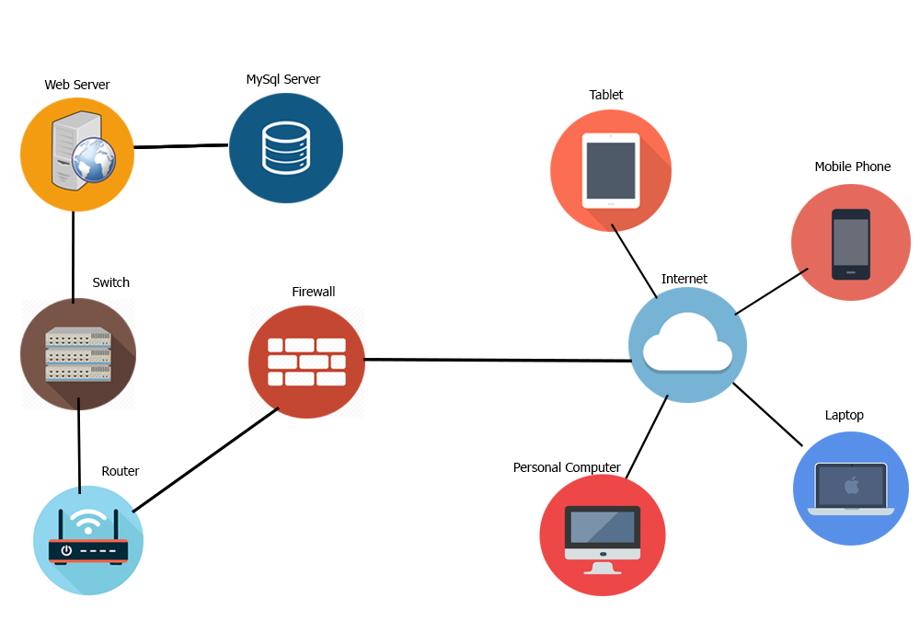 within our system is to safeguard our network from any internet threat or malicious attack coming from different untrusted sites.

Figure 43: Network Model

#### **Network Topology**

Network topology is the arrangement of the various elements (links, nodes, etc.) of a computer network essentially it is the topological structure of a network and may be depicted physically or logically. Distances between nodes, physical interconnections, transmission rates, or signal types may differ between two networks, yet their topologies may be identical. Conversely, mapping the data flow between the components determines the logical topology of the network. Our network topology is star which consists of a central node, to which all other nodes are connected; this central node provides a common connection point for all nodes through a hub. In a star topology, every node (computer workstation or any other peripheral) is connected to a central node called a hub or switch. Using this technology, it helps to develop an efficient and high portable quality of service mechanisms to perform tasks in a secure manner.

# **Development/Construction/Build Phase**

The build phase shows how the system was developed. This comprised the Technology Stack Diagram, Software Specification and Hardware Specification.

### **Technology Stack Diagram**

A technology stack is a combination of software products and programming languages used to create a web or mobile application. Applications have two software components: client side and server-side, also known as front-end and back-end.

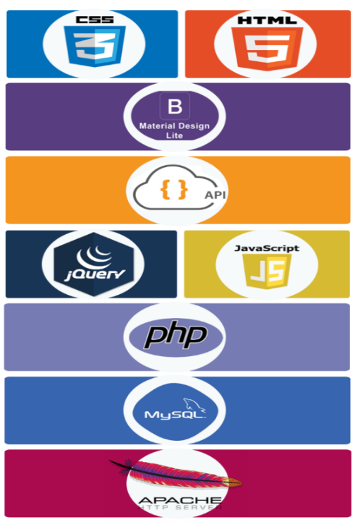

Figure 44: Technology Stack

The figure 44 shows that PassersMate will acquire some of the latest and most commonly used technologies. Some of these technologies are found and free for download from the internet. HTML, with HTML 5 will be used to structure the foundation of the web platform and CSS, with CSS 3 as the core web customization cascading style sheet language. To enhance the web platform’s layout and design elements, PassersMate will use a styling library called Bootstrap. The web platform would also be supported by JavaScript for its functionalities and interactivity. PHP framework would also be adopted by the proponents for enhanced user interactivity. The proponents will use easily accessible technologies in developing the system.

### **Program Specification**

The network design shows how the system was designed. This comprised the network model and topology.

#### **List of Modules**

The list of modules is taken from the major and sub modules of the functional decomposition diagram where it was translated into program modules during the development of the platform.

Table 24

LIST OF MODULES

|  |  |  |  |  |
| --- | --- | --- | --- | --- |
| **Programmer** | **Modules** | **Passer** | **Service Seeker** | **Admin** |
| Marvee Yofa Franco | **A. Management** | | | |
| 1. Passer’s Account | | | |
| 1.1 Create | **** |  |  |
| 1.2 Update | **** |  |  |
| 1.3 Deactivate | **** |  | **** |
|  | No. of Points (1 point per module per user) | **1** |  | **1** |
| Marvee Yofa Franco | 2. Service Seeker’s Account | | | |
| 2.1 Create |  | **** |  |
| 2.2 Update |  | **** |  |
| 2.3 Deactivate |  | **** | **** |
|  | No. of Points (1 point per module per user) |  | **1** | **1** |
| Syrel Prialde | 3. Switch Account | | | |
| 3.1 Create | **** | **** |  |
| 3.2 Update | **** | **** |  |
| 3.3 Deactivate | **** | **** | **** |
|  | No. of Points (1 point per module per user) | **1** | **1** | **1** |
| Joel Lemuel Abuga | 4. Passer Portfolio | | | |
| 4.1 Create | **** |  |  |
| 4.2 Update | **** |  |  |
| 4.3 Delete |  |  | **** |
|  | No. of Points (1 point per module per user) | **1** |  | **1** |
| Joel Lemuel Abuga | 5. Seeker Portfolio | | | |
| 5.1 Create |  | **** |  |
| 5.2 Update |  | **** |  |
| 5.3 Delete |  |  | **** |
|  | No. of Points (1 point per module per user) |  | **1** | **1** |
| Syrel Prialde | 6. Job Categories | | | |
| 6.1 Create |  |  | **** |
| 6.2 Update |  |  | **** |
| 6.3. Delete |  |  | **** |
|  | No. of Points (1 point per module per user) |  |  | **1** |
| Syrel Prialde | 7. Subscription Plan | | | |
| 7.1 Create |  | **** | **** |
| 7.2 Update |  | **** | **** |
|  |  |  |  |
|  | No. of Points (1 point per module per user) |  | **1** | **1** |
| Syrel Prialde | **B. Transactions** | | | |
| Find Passer |  | **** |  |
| Offer a Job |  | **** |  |
| Receive Job offer | **** |  |  |
| Confirm or Decline Job offer | **** |  |  |
| Generate Employment Agreement |  |  | **** |
| Agree to the Employment Agreement | **** | **** |  |
| Hire Passer |  | **** |  |
| Approve Job Done |  | **** | **** |
| Messaging | **** | **** | **** |
| Request COE | **** |  |  |
| Generate COE |  |  | **** |
| Download COE | **** |  |  |
| Cancel the process | **** | **** |  |
| Approve Cancellation | **** | **** |  |
|  | No. of Points (1 point per module per user) | **8** | **8** | **4** |
| Marvee Yofa Franco | **C. Monitoring** | | | |
| Seekers Credentials Verification |  |  | **** |
| Passers Credentials Verification |  |  | **** |
| Inquire Passers Availability |  | **** |  |
|  | No. of Points (1 point per module per user) |  | **1** | **2** |
| Joel Lemuel Abuga | **D. Reports** | | | |
| Job Histories of Passer | **** |  |  |
| Transaction Histories of Seeker |  | **** |  |
| Passer & Seeker Ratings and Reviews | **** | **** |  |
|  | Report and Dispute | **** | **** | **** |
|  | No. of Points (1 point per module per user) | **3** | **3** | **1** |
| Syrel Prialde | **E. Notifications** |  |  |  |
| Job Offer Status | **** | **** |  |
| Notify SMS | **** | **** | **** |
| Dispute Status | **** | **** | **** |
|  | No. of Points (1 point per module per user) | **3** | **3** | **3** |
|  | No. of Modules per User (equals no. of points per user) | **17** | **19** | **16** |
|  | **Total Number of Modules** | **52** | | |

The table 24 exhibits the list of modules from the five major modules of functional decomposition diagram of the system. On the right side where it shows the passer, service seeker and admin are from the use case diagram of the system which determines who can manage, transact, operate, can report or have reports and notifications.

# **Testing or Quality Assurance Phase**

Before PassersMate is released as a web application, it undergoes a through testing process to ensure that the application is working in the manner in which it was intended.

These are the four main stages of testing that need to be completed before a program can be cleared for use: unit testing, integration testing, alpha testing and acceptance testing.

### **Unit Testing**

Unit testing is a level of software testing that where individual units or components of software are tested. The purpose is to validate that each unit of the software performs as designed. A unit is the smallest testable part of software.

Table 25

UNIT TESTING

|  |  |  |  |  |  |  |  |
| --- | --- | --- | --- | --- | --- | --- | --- |
| **Module Name** | **Unit Name** | **Date Tested** | **Test Case ID** | **Test Case Description** | **Expected Result** | **Actual Result** | **Remarks** |
| **Passer Management** | Create Passer |  | U1 | Valid credentials provided and passer info | Account successfully created | Performed as expected | Passed |
|  | Update Passer |  | U2 | Valid updated information provided | Account successfully updated | Performed as expected | Passed |
|  | Delete Passer |  | U3 | Delete account | A message must be displayed | Performed as expected | Passed |
| **Seeker Management** | Create Seeker |  | U4 | Valid information provided | Account successfully created | Performed as expected | Passed |
|  | Update seeker |  | U5 | Valid updated information provided | Account successfully updated, a message must be displayed | Performed as expected | Passed |
|  | Delete seeker |  | U6 | Delete account | A message must be displayed | Performed as expected | Passed |

Table 26

UNIT TESTING – CONTINUATION

|  |  |  |  |  |  |  |  |
| --- | --- | --- | --- | --- | --- | --- | --- |
| **Switch account Management** | Create to switch passer and vice versa |  | U7 | Valid credentials provided and passer info | Switch account successfully created | Performed as expected | Passed |
|  | Update switch account |  | U8 | Valid updated information provided | Switch account successfully updated | Performed as expected | Passed |
|  | Delete switch account |  | U9 | Delete account | A message must be displayed | Performed as expected | Passed |
| **Passer Portfolio Management** | Create Passer’s portfolio |  | U10 | Valid documents provided | Passer’s portfolio successfully created | Performed as expected | Passed |
|  | Update Passer’s portfolio |  | U11 | Valid updated information provided | Passer’s portfolio successfully updated, a message must be displayed | Performed as expected | Passed |
|  | Delete portfolio |  | U12 | Delete passer’s portfolio | A message must be displayed | Performed as expected | Passed |
| **Seeker Portfolio Management** | Create Seeker’s portfolio |  | U13 | Valid documents provided | Seeker’s portfolio successfully created | Performed as expected | Passed |
|  | Update Seeker’s portfolio |  | U14 | Valid updated information provided | Seeker’s portfolio successfully updated, a message must be displayed | Performed as expected | Passed |
|  | Delete portfolio |  | U15 | Delete seeker’s portfolio | A message must be displayed | Performed as expected | Passed |
| **Job Categories Management** | Create Job Category |  | U16 | Valid non-existing type of job category | Job category successfully added | Performed as expected | Passed |

Table 27

UNIT TESTING – CONTINUATION

|  |  |  |  |  |  |  |  |
| --- | --- | --- | --- | --- | --- | --- | --- |
|  | Update Job category |  | U17 | Valid updated non-existing job category | Job category successfully updated | Performed as expected | Passed |
|  | Delete Job Category |  | U18 | Delete job category | A message must be displayed job category deleted | Performed as expected | Passed |
| **Subscription Plan Management** | Create Subscription plan |  | U19 | Valid requirements provided | A Subscription plan successfully created | Performed as expected | Passed |
|  | Update Subscription plan |  | U20 | Valid requirements updated | A Subscription plan successfully updated | Performed as expected | Passed |
| **PassersMate Transactions** | Find Passer |  | U21 | Existing Passer to search to match | Display Passer matches to search | Performed as expected | Passed |
|  | Offer a Job |  | U22 | Seeker offer a job to desired passer | A message must be displayed, offer job sent | Performed as expected | Passed |
|  | Receive Job offer |  | U23 | Passer receive job offer from seeker | A message must be displayed, job offer receive | Performed as expected | Passed |
|  | Confirm or Decline Job offer |  | U24 | Passer confirm or decline the job offer from seeker | A message must be displayed, job offer accepted or decline | Performed as expected | Passed |
|  | Generate Employment Agreement |  | U25 | PassersMate generate employment agreement for passer and seeker | A message must be displayed | Performed as expected | Passed |
|  | Agree to the Employment Agreement |  | U26 | Passer and seeker agrees to the Employment agreement | Employment agreement has been added | Performed as expected | Passed |
|  | Hire Passer |  | U27 | Seeker hires the passer | A message must be displayed | Performed as expected | Passed |

Table 28

UNIT TESTING – CONTINUATION

|  |  |  |  |  |  |  |  |
| --- | --- | --- | --- | --- | --- | --- | --- |
|  | Approve Job Done |  | U28 | Valid updated non-existing job category | Job category successfully updated | Performed as expected | Passed |
|  | Messaging |  | U29 | Delete job category | A message must be displayed job category deleted | Performed as expected | Passed |
|  | Request COE |  | U30 | Valid requirements provided | A Subscription plan successfully created | Performed as expected | Passed |
|  | Generate COE |  | U31 | Valid requirements updated | A Subscription plan successfully updated | Performed as expected | Passed |
|  | Download COE |  | U32 | Existing Passer to search to match | Display Passer matches to search | Performed as expected | Passed |
|  | Cancel the process |  | U33 | Seeker offer a job to desired passer | A message must be displayed, offer job sent | Performed as expected | Passed |
|  | Approve cancellation |  | U34 | Passer receive job offer from seeker | A message must be displayed, job offer receive | Performed as expected | Passed |
|  | Confirm or Decline Job offer |  | U35 | Passer confirm or decline the job offer from seeker | A message must be displayed, job offer accepted or decline | Performed as expected | Passed |
|  | Generate Employment Agreement |  | U36 | PassersMate generate employment agreement for passer and seeker | A message must be displayed | Performed as expected | Passed |
|  | Agree to the Employment Agreement |  | U37 | Passer and seeker agrees to the Employment agreement | Employment agreement has been added | Performed as expected | Passed |

Table 29

UNIT TESTING – CONTINUATION

|  |  |  |  |  |  |  |  |
| --- | --- | --- | --- | --- | --- | --- | --- |
|  | Hire Passer |  | U38 | Seeker hires the passer | A message must be displayed hired passer is created | Performed as expected | Passed |
|  | Approve Job done |  | U39 | Seeker updates the job status | Job status is being updated, A message must be displayed | Performed as expected | Passed |
|  | Messaging |  | U40 | Passer and seeker can update thru chat | Chat box are shown | Performed as expected | Passed |
|  | Request COE  Generate COE  Download COE |  | U41 | PassersMate generates COE for passer after being requested | A message must be displayed, COE created, COE downloaded | Performed as expected | Passed |
|  | Cancel the process |  | U42 | Passer and seeker cancel the process | A job status is canceled, a message must be displayed | Performed as expected | Passed |
|  | Approve cancellation |  | U43 | PassersMate approves cancellation of job status | A message must be displayed, job status is inactive | Performed as expected | Passed |
| **PassersMate Monitoring** | Seeker credentials verification |  | U44 | Valid credentials provided and seeker info | A message must be displayed, wait for the confirmation of the admin | Performed as expected | Passed |
|  | Passer credentials verification |  | U45 | Valid credentials provided and passer info | A message must be displayed, wait for the confirmation of the admin | Performed as expected | Passed |
|  | Passers Availability |  | U46 | Passer status is monitored | Passer status is updated if ongoing or not | Performed as expected | Passed |
| **PassersMate Reports** | Job history of passer |  | U47 | Passer job history summary | View all job history for passer | Performed as expected | Passed |

Table 30

UNIT TESTING – CONTINUATION

|  |  |  |  |  |  |  |  |
| --- | --- | --- | --- | --- | --- | --- | --- |
|  | Transaction history of seeker |  | U48 | Seeker transaction history summary | View all transaction for seeker | Performed as expected | Passed |
|  | Passer and seeker rate and review |  | U49 | Rate and review for passer and seeker | Rate and review has been added | Performed as expected | Passed |
|  | Report and Dispute |  | U50 | Report passer or seeker | Report or dispute has been added | Performed as expected | Passed |
| **PassersMate notification** | Job offer status |  | U51 | Notification on passer | A notification will show, an offer job | Performed as expected | Passed |
|  | Notify SMS |  | U52 | Notification on passer and seeker via SMS | Notification will show via SMS | Performed as expected | Passed |
|  | Dispute status |  | U53 | Notification on passer and seeker about dispute | Notification will show, a dispute to passer or seeker | Performed as expected | Passed |

### **Integration Testing**

Integration testing is a level of software testing where individual units are combined and tested as group. The purpose of this level of testing is to expose faults in the interaction between integrated units. Test drivers and test subs are used to assist in Integration Testing.

Table 31

INTEGRATION TESTING

|  |  |  |  |  |  |
| --- | --- | --- | --- | --- | --- |
| **Module 1** | **Integration process** | **Module 2** | **Pre-condition** | **Result** | **Remarks** |
| Passer profile | Passer can make a portfolio under an existing account | Passer’s account | Passer’s account should exist | Performed as expected | **✓** |
| Seeker profile | Seeker can make a portfolio under an existing account | Seeker’s account | Seeker’s account should exist | Performed as expected | **✓** |
| Account Management | Admin can deactivate or activate under an existing account | Passers account | Passer account should exist | Performed as expected | **✓** |
| Account Management | Admin can deactivate or activate under an existing account | Seekers account | Seeker account should exist | Performed as expected | **✓** |

### **Alpha Testing**

To evaluate the systems actual performance, the proponents did operational testing by potential users. The proponents used this testing method to determine whether a system satisfies it’s acceptance to enable criteria to enable the respondent to determine whether to accept the system.

Table 32

ALPHA TESTING

|  |  |  |  |  |
| --- | --- | --- | --- | --- |
| **Test Criteria** | **Poor** | **Fair** | **Good** | **Very good** |
| **Graphical User Interface (GUI)** | | | | |
| Consistency (The user interface is of the same formatting style and icons throughout the system.) |  | **✓** |  |  |
| Reusability (The system contains reusable GUI components such as familiar buttons, text and check boxes, and other tools.) |  |  |  | **✓** |
| Forgiveness and Tolerance (The interface displays message or confirmation prompts that would allow the users to undo or redo critical actions.) |  |  |  | **✓** |
| Simplicity (The GUI design include simple GUI buttons, such as simple screens with clear, uncrowded messages.) |  |  | **✓** |  |
| Readability (the interface has appropriate colors, font sizes, and styles that is convenient to the target users.) |  |  | **✓** |  |
| Clarity (Displayed error, help, and warning messages are clear, concise, and as elementary as possible to assist user in operating the software. |  |  |  | **✓** |
| Flexibility (The system includes user preferences setting to allow changes, for example, increasing the font size.) |  | **✓** |  |  |
| User-friendliness (The GUI design must be user-friendly, by providing helpful, courteous, and non-offending messages.) |  |  |  | **✓** |
| **System Performance** | | | | |
| Conformance to the Requirements (The system effectively met all the identified features and/or requirements.) |  |  | **✓** |  |
| Conformance to the Objectives (All specific objectives of the system are met by the program.) |  |  |  | **✓** |
| Efficiency (The entire system functions efficiently. It doesn’t have delay in any transaction.) |  |  |  | **✓** |
| Security (The system is secured. Login details are authenticated. Input parameters are ensured prior to the execution of the next transaction.) |  |  |  | **✓** |
| Integrity (The software allows the registered user to have control over its own private information. |  |  |  | **✓** |
| Overall Impression (In general, the program or system is functional and useful.) |  |  |  | **✓** |

### **Acceptance Testing**

Table 33

ACCEPTANCE TESTING

|  |  |  |  |  |  |  |  |  |
| --- | --- | --- | --- | --- | --- | --- | --- | --- |
| **Project Identification** | | | | | | | | |
| **Project Name** | | | | | | | | **Date Created** |
| PassersMate: An Online job marketplace for Technical and Vocational Skills | | | | | | | |  |
| **Project Sponsor or Owner** | | | | | **Project Manager** | | | |
|  | | | | | Marvee Yofa Franco | | | |
| **Project Adviser** | | | | | **Dean** | | | |
| Mr. Joaquin S. Patiño | | | | | Dr. Melvin M. Niñal | | | |
| **Acceptance Criteria Test Matrix** | | | | | | | | |
|  | | | | **Critical** | | **Test Results** | |  |
| **Number** | | **Acceptance Criterion Description** | | **Yes** | **No** | **Accept** | **Reject** | **Comments** |
|  | |  | | **🞏** | **🞏** | **🞏** | **🞏** |  |
|  | |  | | **🞏** | **🞏** | **🞏** | **🞏** |  |
|  | |  | | **🞏** | **🞏** | **🞏** | **🞏** |  |
|  | |  | | **🞏** | **🞏** | **🞏** | **🞏** |  |
|  | |  | | **🞏** | **🞏** | **🞏** | **🞏** |  |
|  | |  | | **🞏** | **🞏** | **🞏** | **🞏** |  |
|  | |  | | **🞏** | **🞏** | **🞏** | **🞏** |  |
|  | |  | | **🞏** | **🞏** | **🞏** | **🞏** |  |
|  | |  | | **🞏** | **🞏** | **🞏** | **🞏** |  |
|  | |  | | **🞏** | **🞏** | **🞏** | **🞏** |  |
| **Other Considerations** | | | | | | | | |
| **Business Objectives – Did the software application or system meet the business objectives?** | | | | | | | | |
| **Yes**  **🞏** | | **No**  **🞏** | **<Specifically state whether the software application or system met each of the requirements a stated in the Requirements Specifications.>** | | | | | |
| **Does the software application or system require any changes prior to installation? If so, please describe.** | | | | | | | | |
| **Yes**  **🞏** | | **No**  **🞏** | **<Identify and document any other changes or requirements that may be necessary for initial installation.>** | | | | | |
| **Approval** | | | | | | | | |
| **Project Sponsor/ Project Owner** | | | **Signature** | | | | | **Date** |
| **Yes**  **🞏** | **No**  **🞏** | |  | | | | |  |

# **Implementation or Deployment Phase**

|  |  |  |  |
| --- | --- | --- | --- |
| **Cost Specification** | | | |
| A. | Supplies  Compact Disk | |  |
| Php 20.00 |
|  | Sticker  Photocopies  Bookbinding | | Php 30.00 |
| B. | Php 900.00 |
| C. | Php 200.00 |
|  |  | |  |
|  | **TOTAL** | | **Php 1,150.00** |
| **Investment Cost** | | | |
|  | Needed Capital | Php 600,000 | |
|  |  | |  |
|  | Breakdown: | |  |
|  | * 70% - Salaries and Production | |  |
|  | * 20% - Hosting, Data Centers or Servers | |  |
|  | * 10% - Ads, General and Administrative Expenses (Office rental, utilities, etc.) | |  |

### **Software Specification**

Software specification is a complete description of the behavior of the system to be developed. It fully describes what the system will do and how it will be expected to perform.

Table 22

SOFTWARE SPECIFICATION

|  |  |
| --- | --- |
| Components | Description |
| Web Server Application Software | Apache Tomcat v8.5.4 |
| Web Development Tool | PHP, HTML, CSS, JavaScript, Bootstrap |
| Database Management System | MySQL |
| Text Editing Tool | Sublime Text 3 |
| Image Editor | Adobe Photoshop CS6 or higher |
| Web Operating System | Windows XP, Windows 7(recommended), Windows 8, Windows 8.1, Windows 10 |
| Web Browser | Internet Explorer, Mozilla Firefox, Google Chrome, Safari, Opera, Microsoft Edge |

The table 22 shows the software specifications of the system. It is composed of various components such as the operating system -a software program that enables the computer hardware to communicate and operate with the computer software; And the web browsers; as well as other components like DBMS, editors and various tools related to the design and development of the system.

### **Hardware Specification**

The researchers determine the hardware specifications in order to be familiar on specifications needed for the system to be fully functional.

Table 23

HARDWARE SPECIFICATION

|  |  |
| --- | --- |
|  | **Description** |
| 1. Web Based | **Processor (CPU):**  Intel Core i3 3.2 GHz or higher  **Hard Disk Drive (HDD):**  500 GB  **Random Access Memory (RAM):**  4GB or higher  **Network:**  10/100 Base T Ethernet |
| 1. For Personal Computer | **Processor (CPU):**  Minimum of 1.7 GHz  **Hard Disk Drive (HDD):**  250Gb  **Random Access Memory (RAM):**  Minimum of 2Gb  **System Unit**  **Monitor**  **Keyboard**  **Mouse** |

Table 23 shows the various hardware specifications from minimum specifications to possible higher specifications for the design and development of PassersMate.

### **Human Resources Specification**

Position Needed

1. Hustler (Project Manager and QA tester

* Plan and organize resources and people to make sure projects finish on time, stay within budget and meet the requirements.
* Planning, Executing and Closing Projects – defining the project, building its comprehensive work plan.
* Managing Teams - facilitating commitment and productivity, removing obstacles, and motivating team members.
* Managing Expectations – aligning projects to business goals, managing stakeholders, and communicating project status, milestones, and unexpected difficulties effectively.
* Good at juggling several tasks at the same time, have excellent skills and can lead a team.
* Finding out what the client wants to achieve.
* Agreeing the timescales, costs, and resources needed.
* Drawing up detailed plan and schedule for each stage of the project.
* Selecting and leading a project team.
* Perform their duties under general supervision and are responsible for all aspects of the project for the life of the project.
* Lead and direct cross – functional teams to deliver projects within the constraints of schedule, budget, and resources.
* Demonstrate sufficient knowledge and experience to appropriately apply a methodology to projects that have reasonably well – defined project requirements and deliverables.
* Test, tune, debug and suggest the detailed refinements that ensure the quality of the system.
* Test for bugs in the software, from complete crashes to minor glitches in the program.
* Responsible for assuring quality in the final product and for finding all the flaws in a system before it goes public.
* Responsible for assuring quality in the final product and for finding all the flaws in a system before it goes public.
* Look for program bugs - spelling mistakes, localization problems.

2. Hipster (System Analysis, Database Designer, Network Designer, an UI/UX Designer)

* Work with analysts on the feasibility of a conceptual design by taking technical specifications prepared by the analyst and designing system components to meet the set requirements.
* Draw up detailed design documentation including charts and diagrams that indicate the various components involved.
* Prepare instructions for programmer implementation.
* Talk with other team members (analysts and programmers) to ensure functionality per systems specifications and develop solutions as problems or issues arise.
* Design monitoring and performance measurement processes.
* Work designs and implements computer databases for the collection, protection and analysis of data.
* Analyzing data inquiry needs, ensuring security of information and organizing layout to best present the information needed.
* Responsible for creating functional and visually appealing user interfaces for websites, databases, computer programs and applications.
* Must ensure that icons and features displayed on the interface of a computer program can be easily interpreted by users without excessive explanation, thus making areas where users directly interact with technology, easy and intuitive to use.
* Organize information to be contained on the interface.

3. Hacker (Software engineers/Programmers)

* Must be familiar with many different software programs and can learn to use new software quickly.
* Responsible for the development, maintenance and operation of computer software to enable businesses and organizations to function as efficiently as possible.
* Works with a business analyst or computer programmer to identify the needs of a company and to develop the specifications of the engineering project.
* Skills to write code and create software programs that tell computers to accomplish certain tasks like retrieving data.
* May also rewrite, debug maintain and test these programs.

### **User- Guide**

**WEB - PASSER**

**Sign up**

1. Click Sign- up

2. Choose as Passer

3. Provide information

a. Email (must be a valid email address “[example@gmail.com](mailto:example@gmail.com)”)

b. Password (must contain letters or numbers at least 6 characters

c. upload Competency assessment certificate and details

d. upload Government and valid ID and details

e. Address (current address)

4. Click Sign up (Submit)

**Log In**

1. Choose type of account to log in

2. Provide log in credentials

a. Provide registered email

b. Provide registered password

**Manage Passer Profile**

1. Profile Information

a. Provide working history

b. About me

c. Contact Details

d. Service fee

**WEB - SEEKER**

**Sign up**

1. Click Sign- up

2. Choose as Seeker

3. Provide information

a. Email (must be a valid email address “[example@gmail.com](mailto:example@gmail.com)”)

b. Password (must contain letters or numbers at least 6 characters

c. Upload Government or valid ID and details

d. Address (current address)

4. Click Sign up (Submit)

**Log In**

1. Choose type of account to log in

2. Provide log in credentials

a. Provide registered email

b. Provide registered password

**Manage Passer Profile**

1. Profile Information

a. About me

b. Contact Details

**Choose and Offer a Job**

1. Job offer Information

a. Provide job details

b. Working address

c. Working accommodation details

2. Go to search area

3. Choose preferred passer based on given criteria

4. Go to passer’s profile

5. Click offer job button or message passer

### **Installation Guide**

1. Go to your web browser (Google Chrome, Mozilla Firefox, etc.).
2. Search passersmate.com.
3. Sign in for free and start looking for service provider.

### **Project Roadmap**

In order for PassersMate to keep improving and address its current limitations, a roadmap was conceptualized by the proponents. This can be used by future researches that may continue this system. This is also to see what improvements and new features can and will be added to this platform.

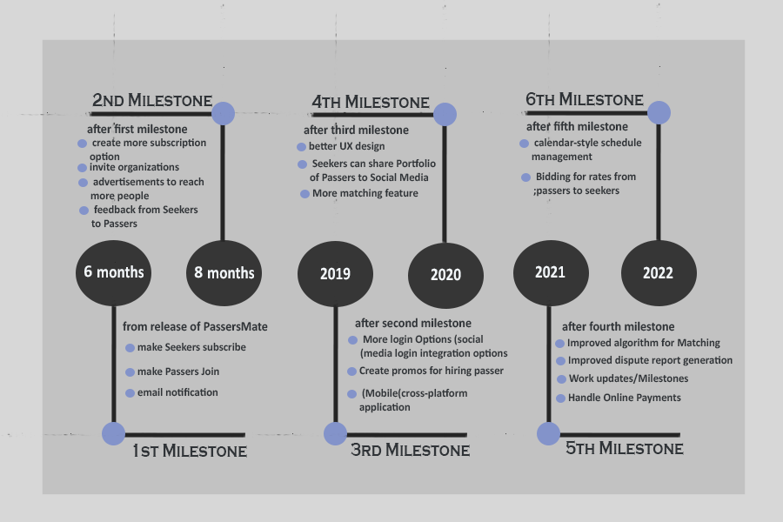

Figure 45: Project Roadmap

# **CONCLUSION**

This research and application’s main purpose is to develop an online job marketplace for technical and vocational skills that will help TESDA passers connect to the possible service seekers by matching the preferred type of job category and the given criteria. The proponents conclude that with the implementation of this application, job opportunities create doors for the TESDA passers. All of the objectives defined in Chapter 1. Passers and service seekers can enjoy the features provided by PassersMate with this application.

In addition to this, PassersMate has a number of features that assures the sustainability of the both sides like matching passers and service seekers by the map functionality and search algorithm, built-in chat feature for the negotiations and agreement of both sides and lastly generates a requested Certificate of Employment for the TESDA passers after they have performed their job with the approval of service seekers. The proponents were able to develop a system that is useful and easy-to- use for passers and service seekers.

# **RECOMMENDATIONS**

PassersMate is scalable and there are a lot of potential and space for improvement and future research. Based on the foregoing findings of this system/study, the following are some recommended future enhancements for PassersMate:

1. Bidding for rates from passers to seekers;

2. Email notification;

3. Improve UI/UX on this platform to catch the user’s attention and for their ease of use;

4. Login Options

5. Improve report generation from disputes;

6. Schedule management;

7. Seeker can like or share Portfolio of a Passer to Social Media;

8. Advertisements to reach more people;

9. More matching options for Seekers;

10. Work Updates/ Milestones;

11. Handle Online Payments;

12. Improve Hiring process;

13. Improve list of chosen passers by the service seeker;

14. Hiring management of passers;

# **REFERENCES**

TESDA. (). *Glossary of TESDA*. Retrieved from TESDA: The%20TVET%20Glossary%20of%20Terms,%204th%20Edition

Forbes (2014, October). *Online Labor Marketplaces*. Retrieved from Forbes: <https://www.forbes.com/sites/groupthink/2014/10/21/the-next-big-thing-in-e-commerce-online-labor-marketplaces/#43738f4d41f5>

Magruder, J. (2015, December). *The impact of online job portals on job search outcomes*. Retrieved from theigc: https://www.theigc.org/blog/click-to-apply-the-impact-of-online-job-portals-on-job-search-outcomes/

TESDA. (n,d).*About TESDA*. Retrieved from TESDA: http://www.tesda.gov.ph/About/TESDA/10

PSA.gov.ph (2017, January). *Employment rate*. Retrieved from theigc: https://psa.gov.ph/content/employment-rate-january-2017-estimated-934-percent

Jaymalin, M. (2017, March). *1 M graduates face unemployment*. Retrieved from Philstar: https://www.philstar.com/headlines/2017/03/14/1678970/1-m-graduates-face-unemployment

Chua, K. (2013, August). *The Philippine Jobs Challenge: How to create more and better jobs?* Retrieved from The World Bank: http://blogs.worldbank.org/eastasiapacific/philippine-jobs-challenge-how-create-more-and-better-jobs

Reyes, T. (2015, March). *The real cost of education in the Philippines.* Retrieved from The Rappler: https://www.rappler.com/brandrap/advocacies/105019-real-cost-education-ph

Raket,ph. (n.d). *How does Raket.ph work?.* Retrieved from Raket: https://raketph.zendesk.com/hc/en-us/articles/205159077-Getting-Started-as-a-Raketeer

Onlinejobs,ph. (n.d). *HOW IT WORKS.* Retrieved from OnlineJobs: https://www.onlinejobs.ph/how/employer

WorkSmart. (n.d). *HOW HAS THE INTERNET IMPROVED THE WAY WE FIND AND APPLY FOR JOBS?.* Retrieved from WorkSmart: https://www.onlinejobs.ph/how/employer

# **CURRICULUM VITAE**

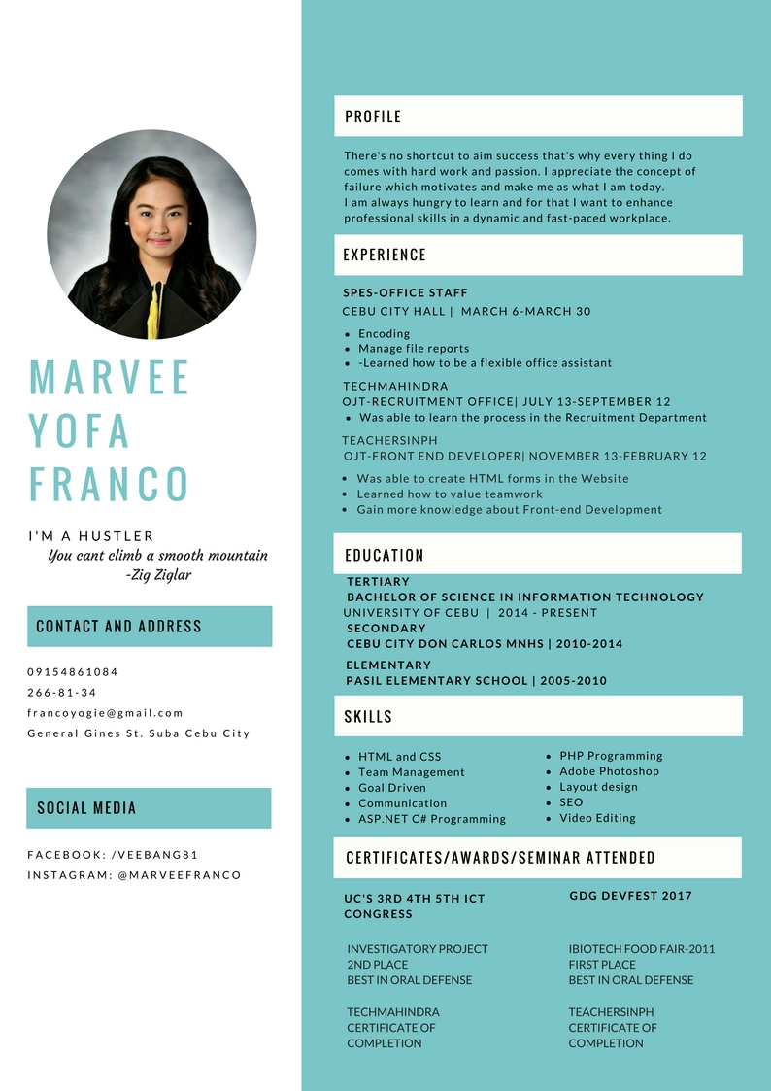

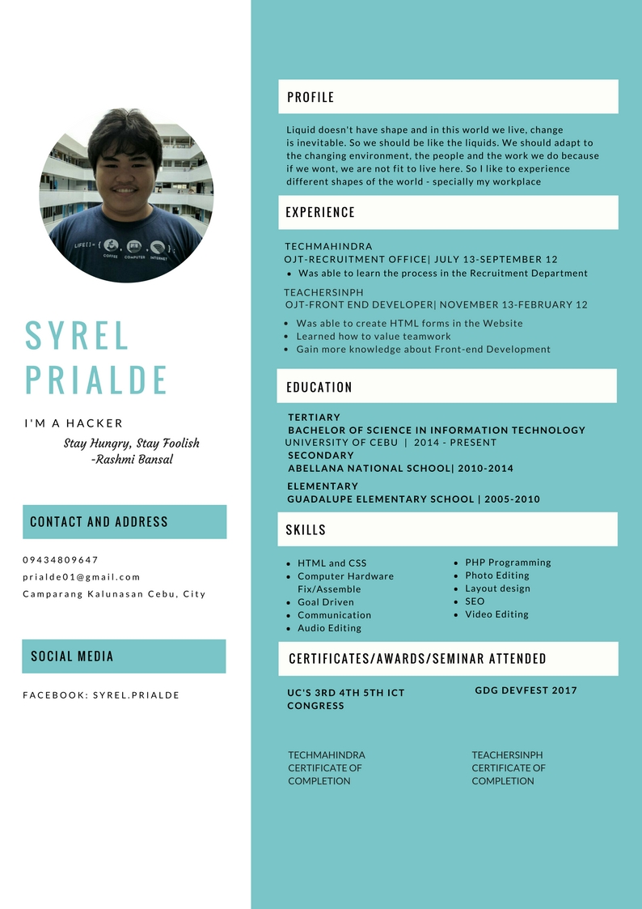



# **APPENDICES**

## **C:\Users\MarveeLoper\Documents\My Bluetooth\IMG_20180316_100610.jpg A. Oath of Confirmation**

**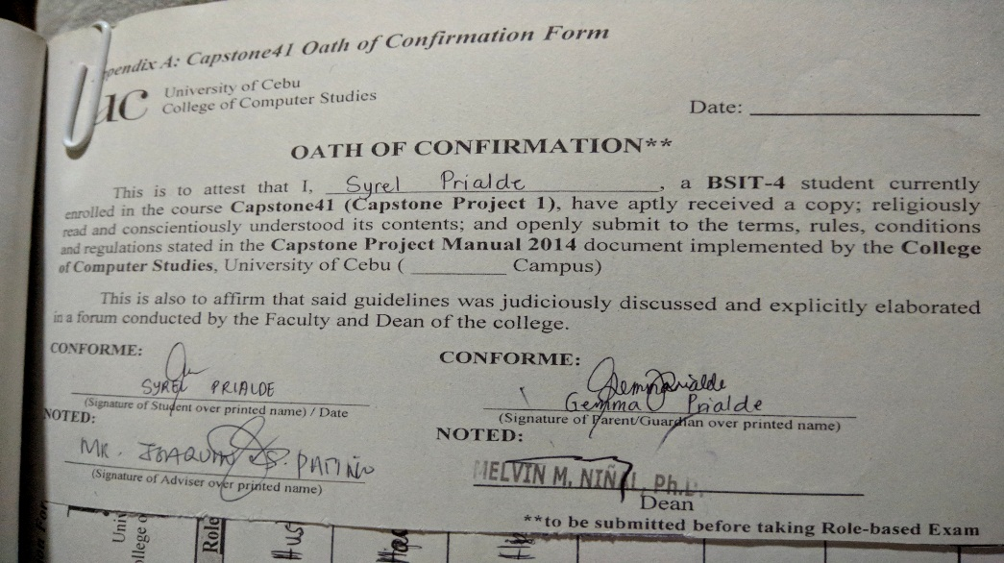**

**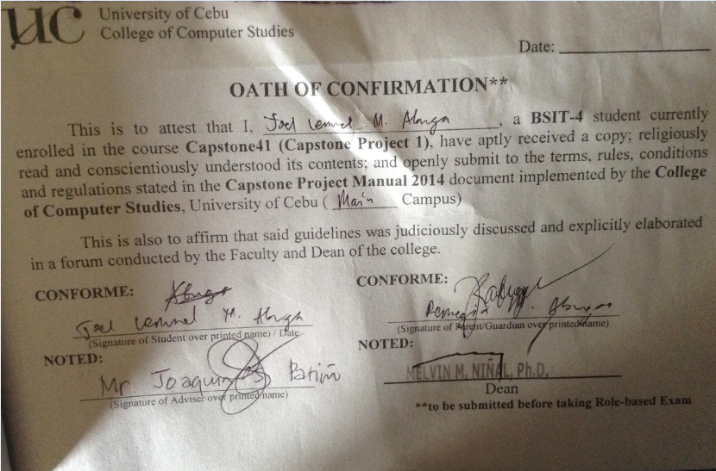**

## **B. Capstone Project Team Composition Form**

**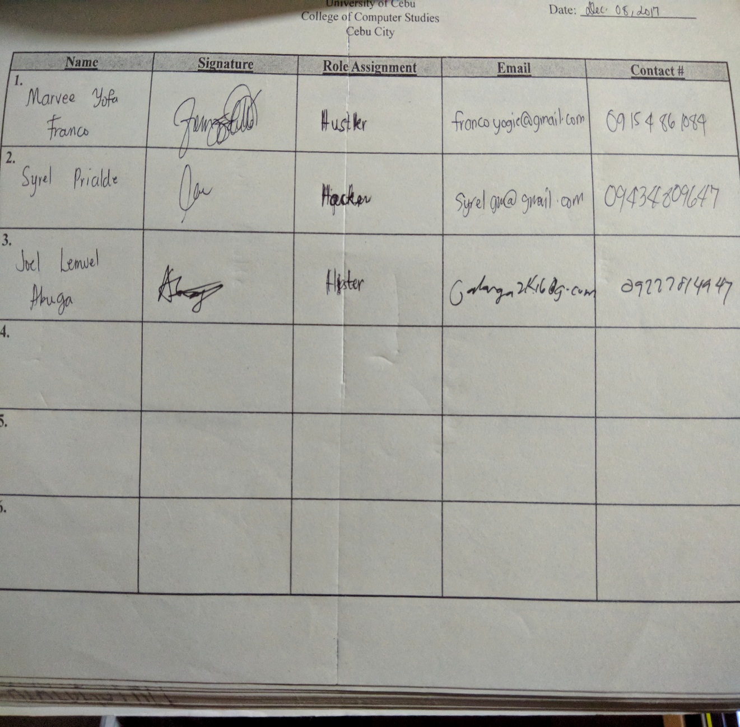**

## **C. Capstone Project Working Title Form**

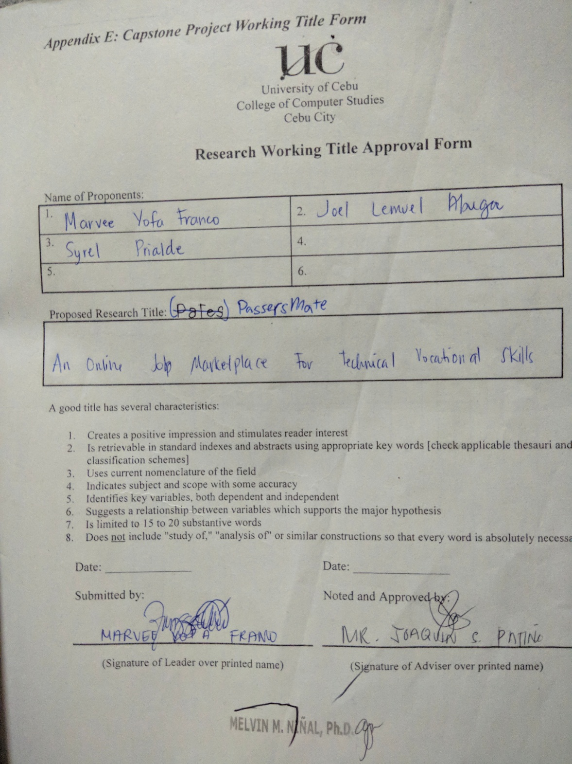

## **D. Consultation Logs**

## **E. Censor’s Certificate**

## **F. Hearing Notice Form**

## **G. Transmittal Letter**

